Instalar a agenda:

Módulo: FullCalendar View
https://www.drupal.org/project/fullcalendar_view
ou vá para Drupal.org > Download > Modules
Em Search modules digite FullCalendar View

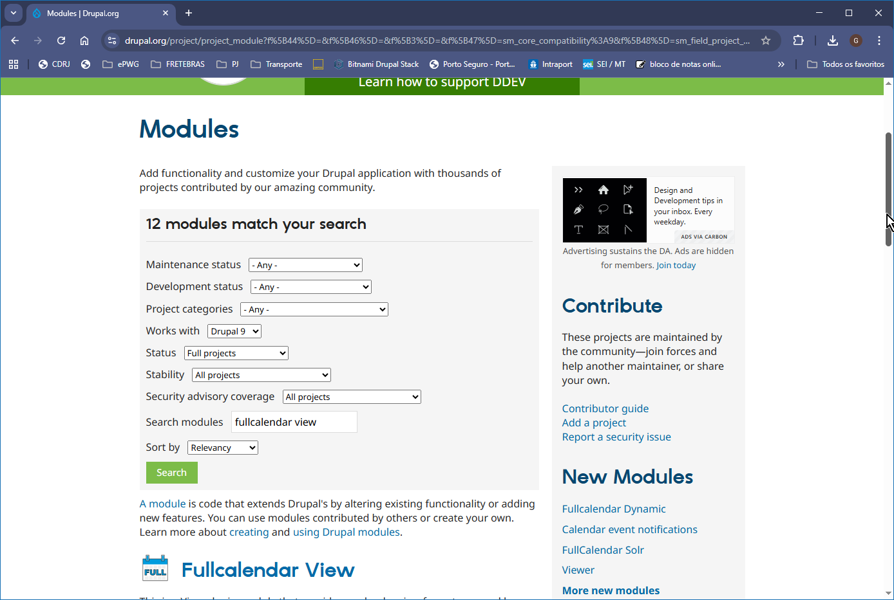

e clique no resultado.
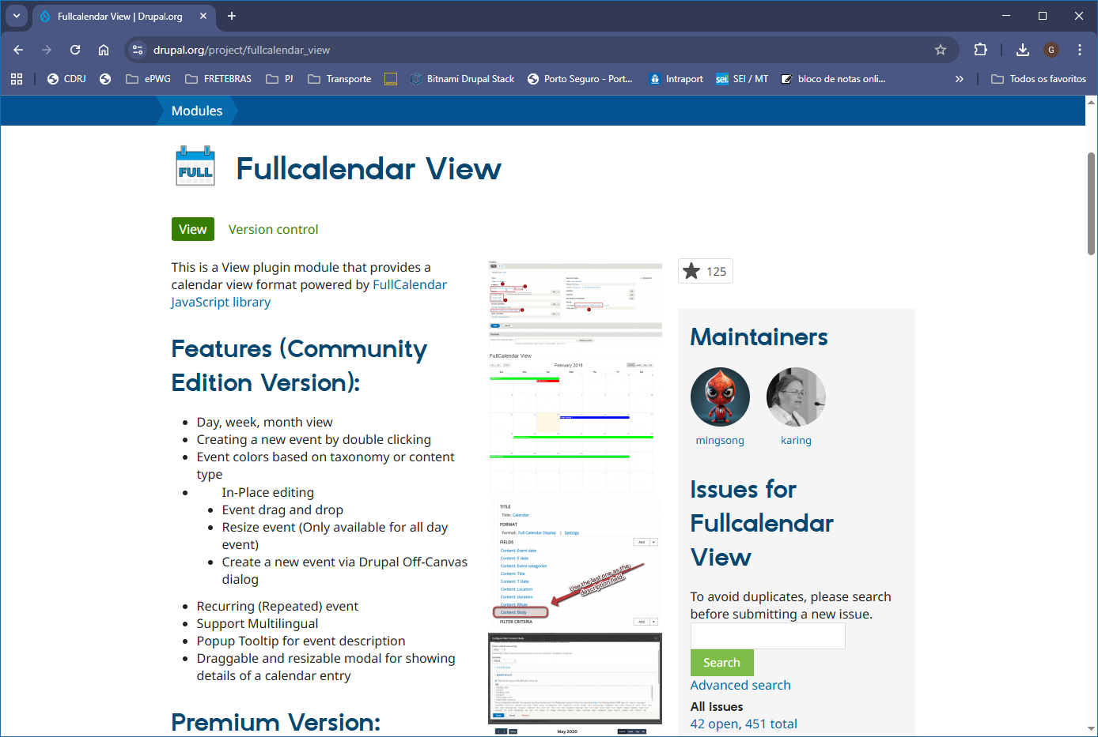

Vá para o fim da página
Em Releases, clique na versão desejada, no nosso caso em 5.1.14
Observe que o módulo indica qual versões do Drupal são compativeis.
Exemplo: a versão 5.4.1 é compativel com as versões do Drupal 9.2.0 e acima e versão 10
Works with Drupal ^9.2.0 || ^10

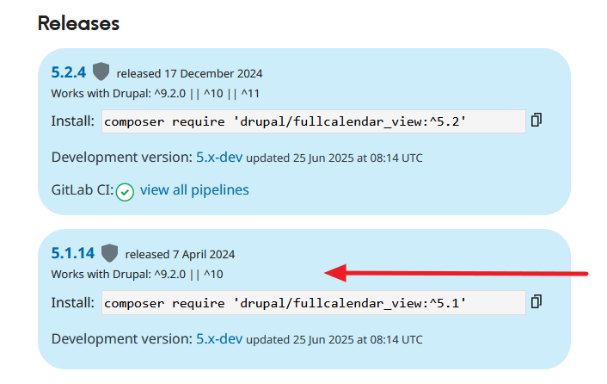
Clique no link: 5.1.14
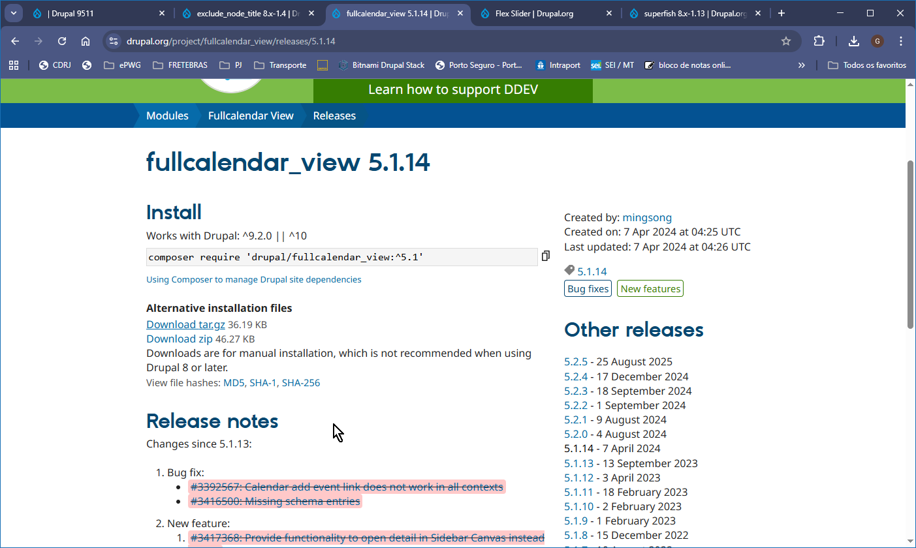
Clique com o botão direito do mouse em Download.tar.gz ou em Download.zip e copie o endereço do link.

Va para o site como administrador.
Administration > Extend > Install new module

Vai abrir a pãgina Add new module
em Add from a URL, cole o endereço do módulo (compactado).
Clique Continue

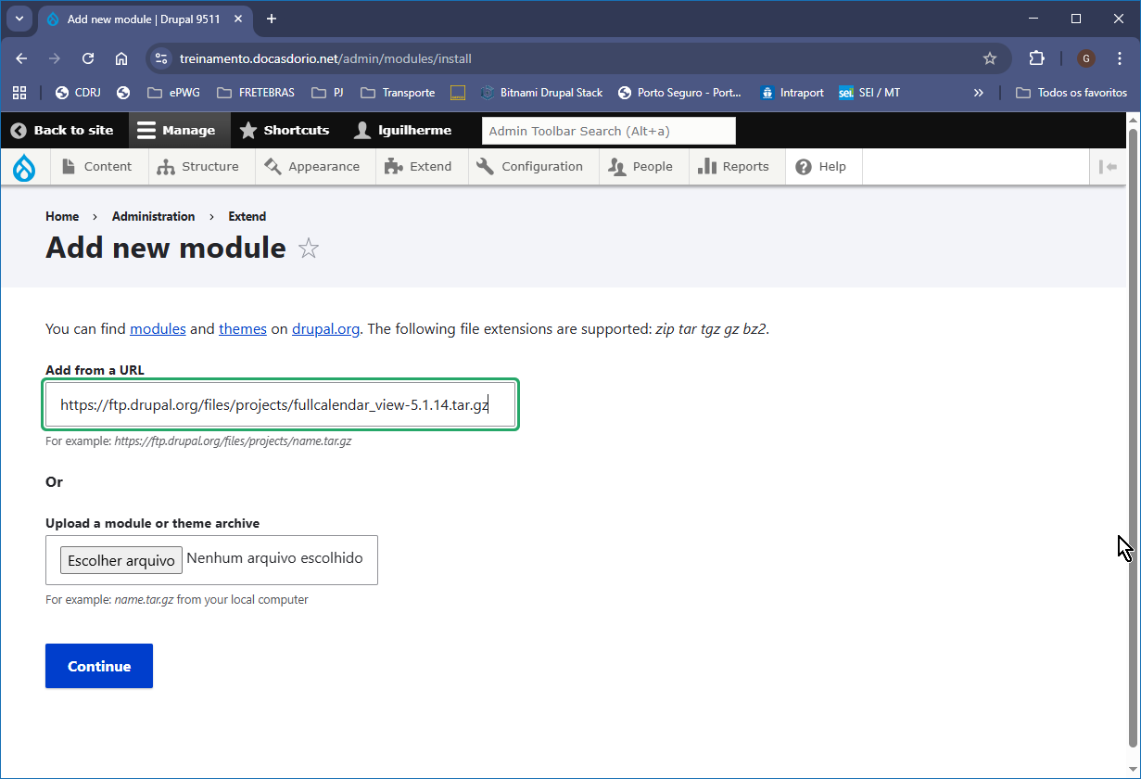
A agenda serã instalada, mas ainda não está ativada.

Para ativar a agenda clique no menu Extend, digite Fullcalendar marque a checkbox e clique Install

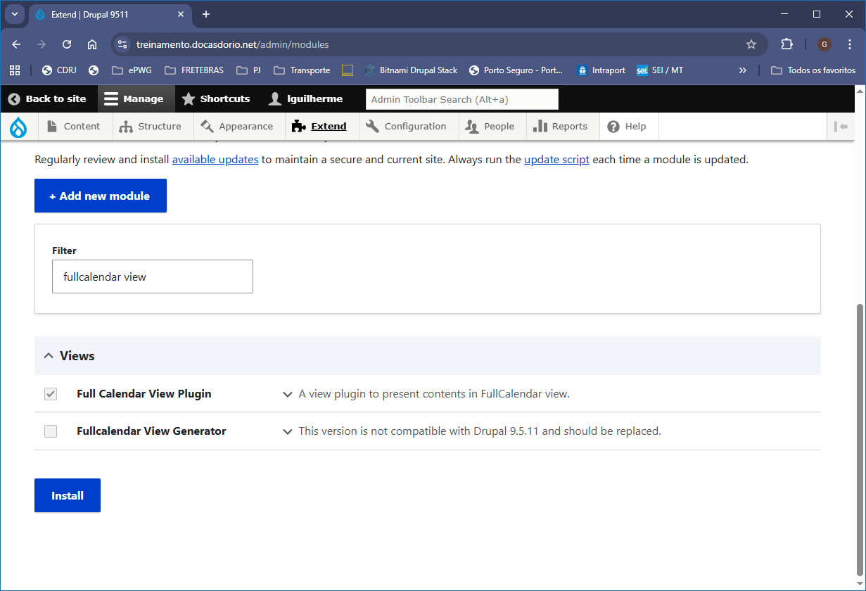

Módulo da Agenda instalada: Fullcalendar View
https://www.drupal.org/project/fullcalendar_view
mesma coisa abaixo, usando outro tema para a interface de adminisração

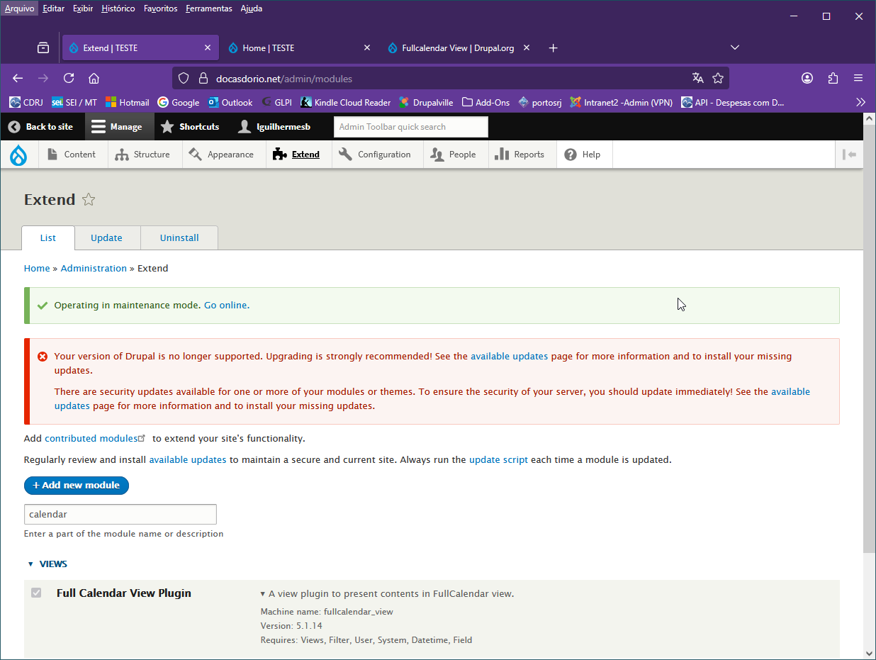

Configurar AGENDA

Exemplo: Criar a agenda da SUPTIN como vista na figura abaixo no site de produção:

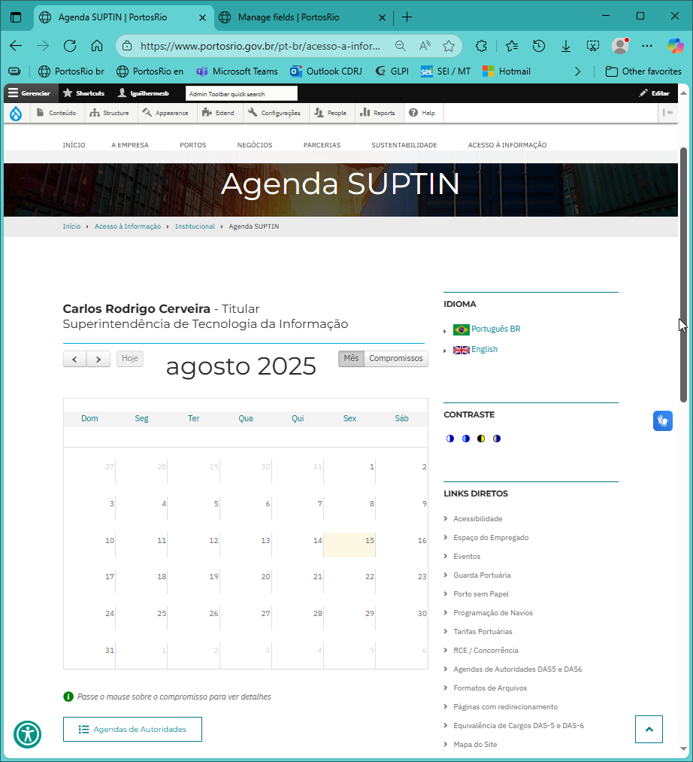

INGREDIENTES:

- Criar Tipo de Conteúdo da agenda SUPTIN
- Criar Grupo de usuários com permissão de editar a agenda SUPTIN
- Atribuir Permissões para o Grupo de usuarios a serem determinadas.

1.Criar o tipo de Conteúdo da agenda SUPTIN
Structure > Content Types > Add Content Type
Tipo de Conteudo (Content Types):
Agenda SUPTIN Page (principal)
Agenda SUPTIN hoje (opcional)

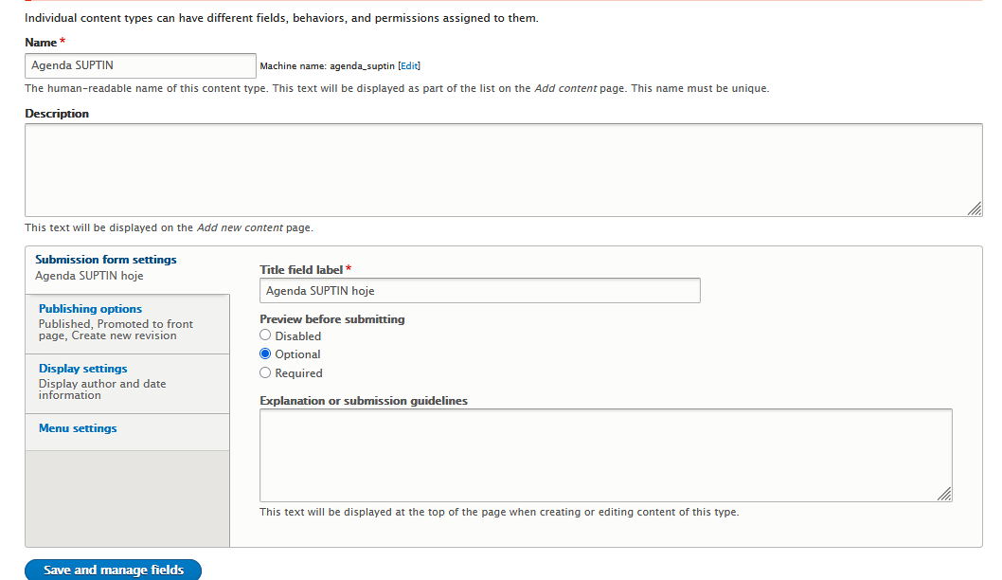
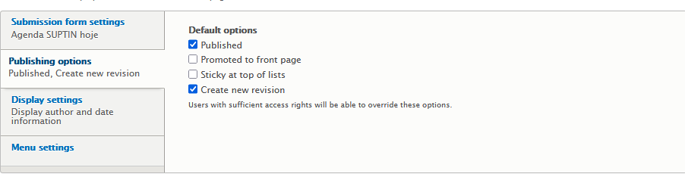
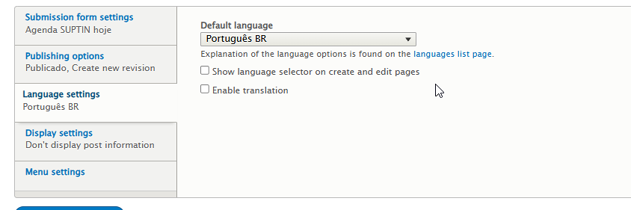
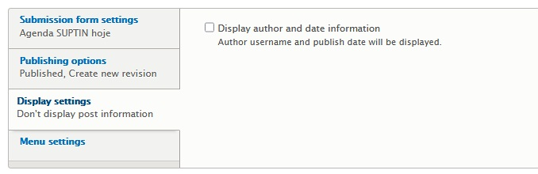

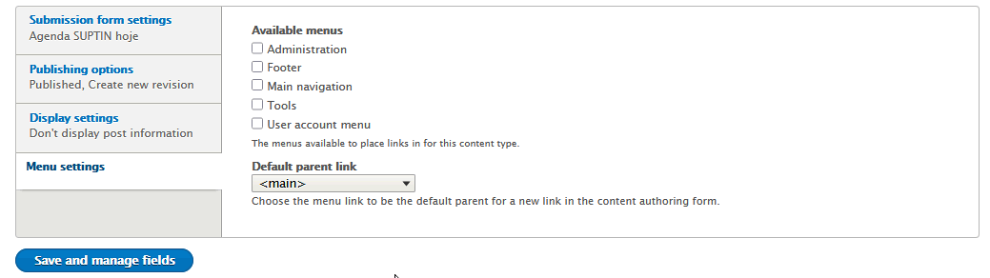

Clique em Save and manage fields para ir para o gerenciamento dos campos do conteudo
Agenda SUPTIN

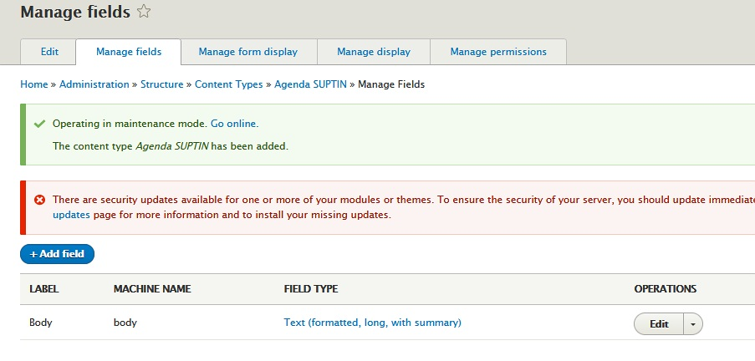

Adicionar os seguintes campos:

Rótulo | Tipo do Campo (Field type )
Agenda SUPTIN - Compromissos | Text (formatted, long)
Agenda SUPTIN - Data | Data
Agenda SUPTIN - Exercício | List (text)
Agenda SUPTIN - Nome | Text (plain)

Remover o campo:
Body

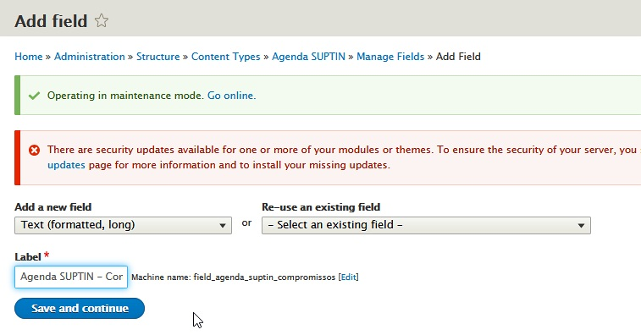
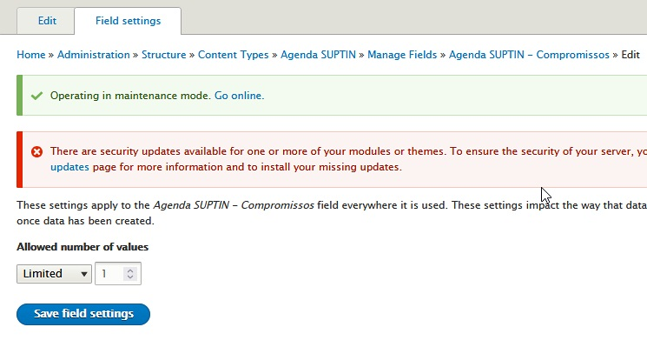
Adicionar campo: Agenda SUPTIN - Compromissos

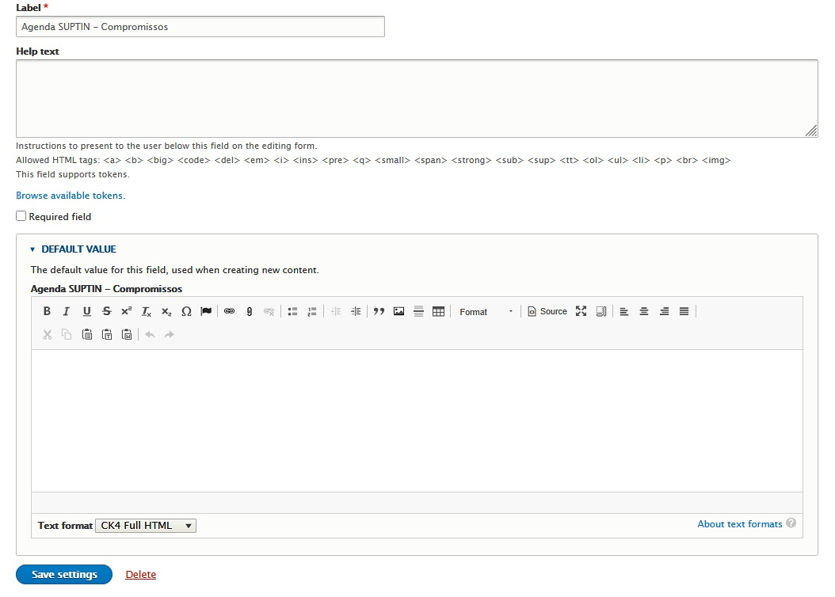
Clique em Save Settings
A tela retorna para o Manage Fields.

Proximo passo: adicionar os campos Data, Exercício e Nome ao formulário

Rótulo | Tipo do Campo (Field type ) | Situação
Agenda SUPTIN - Compromissos | Text (formatted, long) | OK
Agenda SUPTIN - Data | Data
Agenda SUPTIN - Exercício | List (text)
Agenda SUPTIN - Nome | Text (plain)

Adicionar campo: Agenda SUPTIN - Data

Repetir Add Field para Agenda SUPTIN - Data

Add a new field: > Date
Label: > Agenda SUPFIN – Data
[ Save and Continue ]

Date type: > Date only
Limited: > 1
[ Save field settings ]

Default Date: > Current date
[ Save settings ]

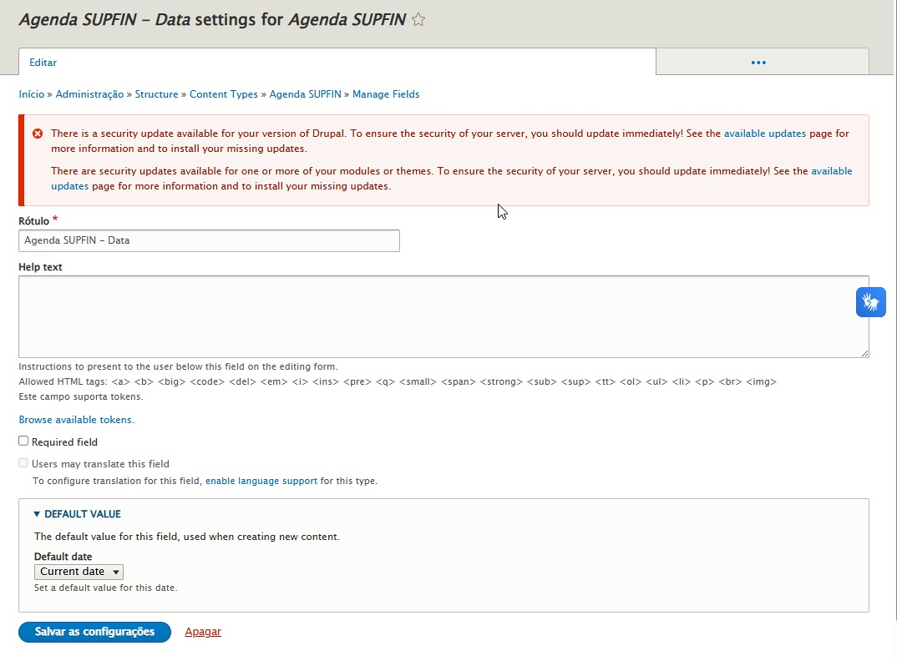

Rótulo | Tipo do Campo (Field type ) | Situação
Agenda SUPTIN - Compromissos | Text (formatted, long) | OK
Agenda SUPTIN - Data | Data | OK
Agenda SUPTIN - Exercício | List (text)
Agenda SUPTIN - Nome | Text (plain)

Adicionar campo: Agenda SUPFIN - Exercício

Tipo do campo: List (text)
Add a new field > List Text
Label: > Agenda SUPFIN – Exercício

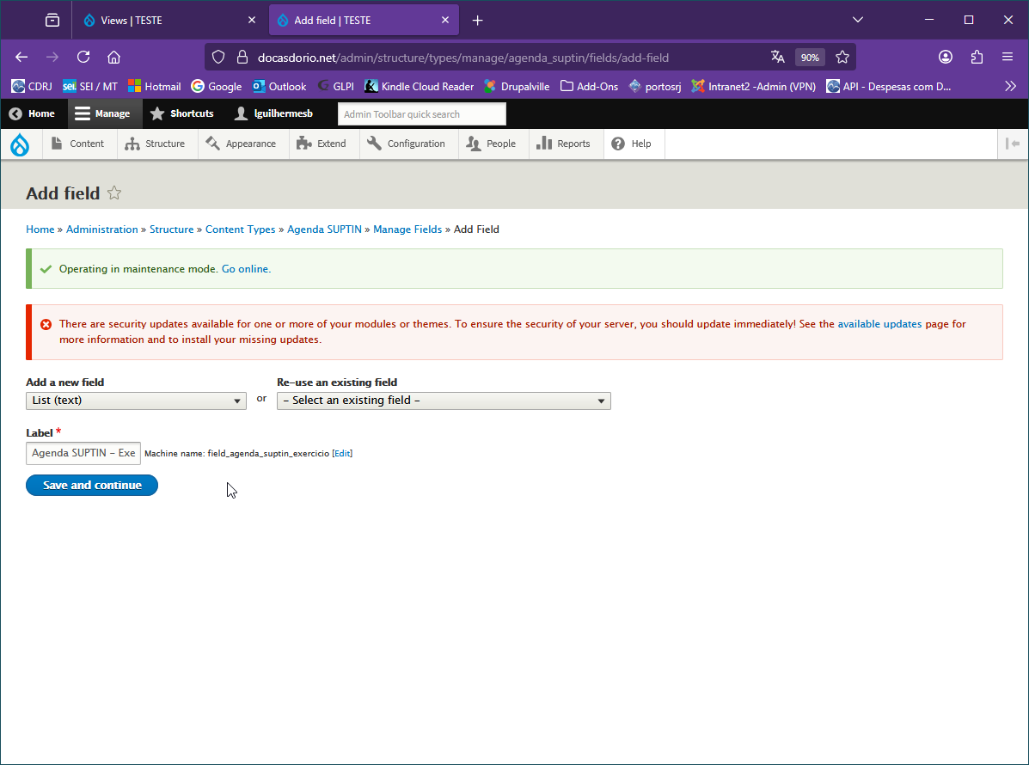

( Save and Continue )

Allowed values list (listagem dos valores permitidos)
Titular|- Titular
Substituto(a)|- Substituto(a)
Limited > 1
(Atençao ao uso da barra vertical “ | ” )

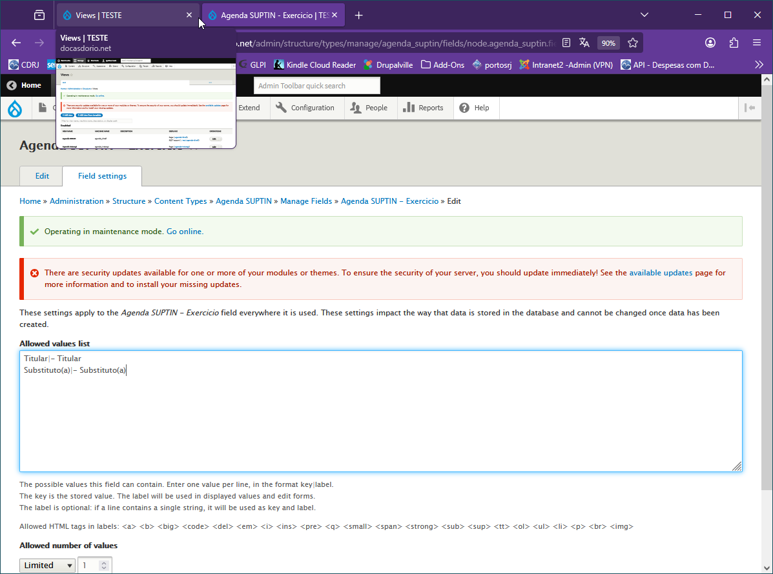

( Save field Settings )

Rótulo | Tipo do Campo (Field type ) | Situação
Agenda SUPTIN - Compromissos | Text (formatted, long) | OK
Agenda SUPTIN - Data | Data | OK
Agenda SUPTIN - Exercício | List (text) | OK
Agenda SUPTIN - Nome | Text (plain)

Adicionar campo: Agenda SUPTIN - Nome

Add field > Agenda SUPTIN – Nome
Select a field type: > Text Plain
Label: > Agenda SUPTIN – Nome
( Save and continue )

Maximum length > 50 (default era 255)
Limited: > 1

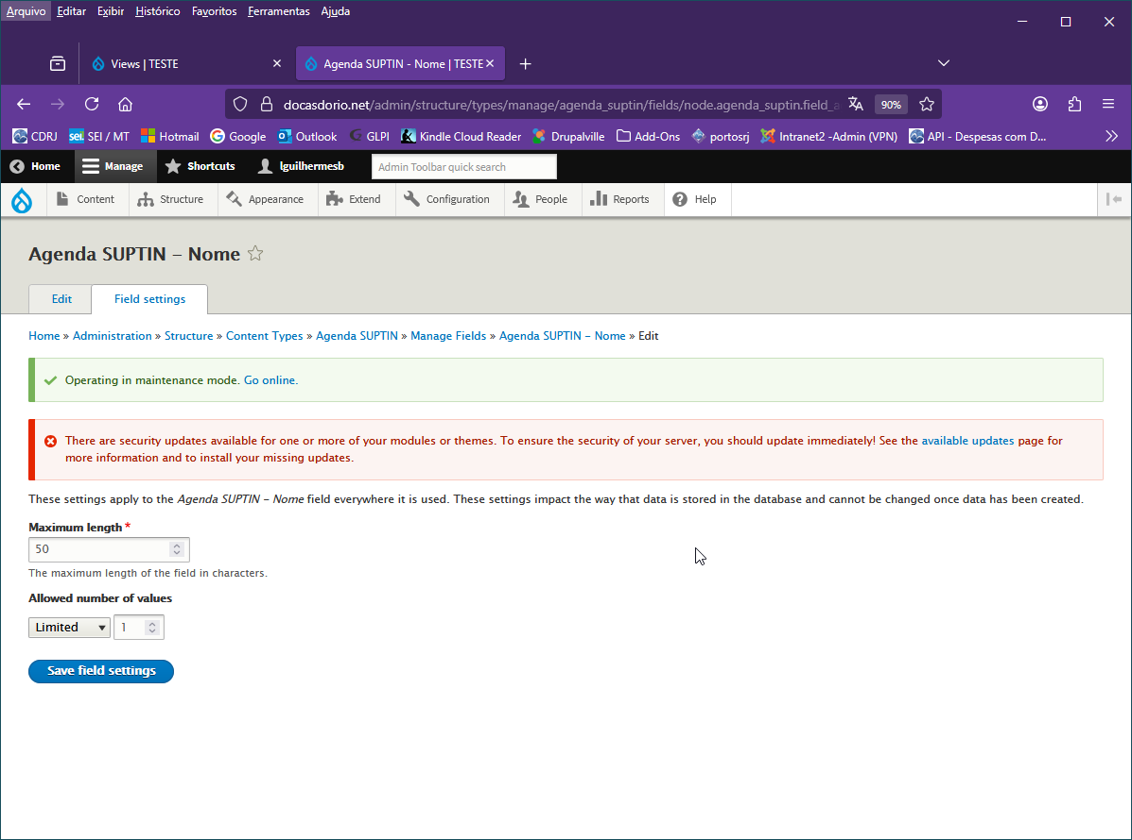
( Save field settings )

Marca campo obrigatório – Required field
DEFAULT VALUE :
Agenda SUPTIN – Nome > Superintendente de TI
Observação: mais tarde pode ser editado.

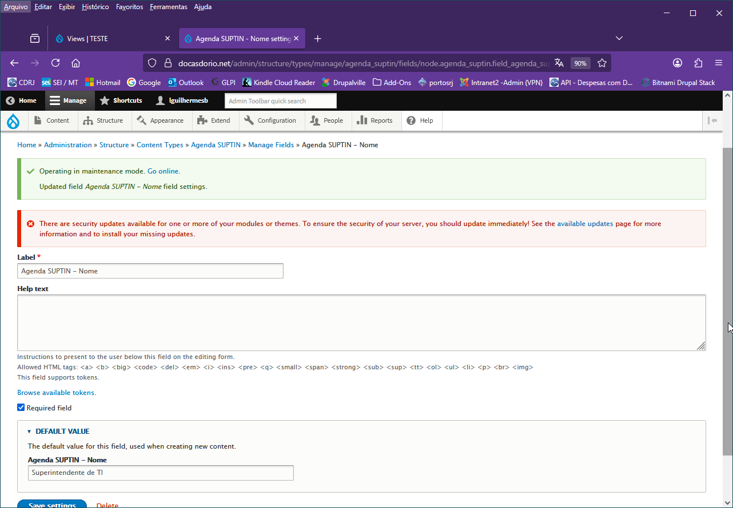

(Save Settings )

Rótulo | Tipo do Campo (Field type ) | Situação
Agenda SUPTIN - Compromissos | Text (formatted, long) | OK
Agenda SUPTIN - Data | Data | OK
Agenda SUPTIN - Exercício | List (text) | OK
Agenda SUPTIN - Nome | Text (plain) | OK

Seguimos para organizar a aba Manage form display

Manage form display

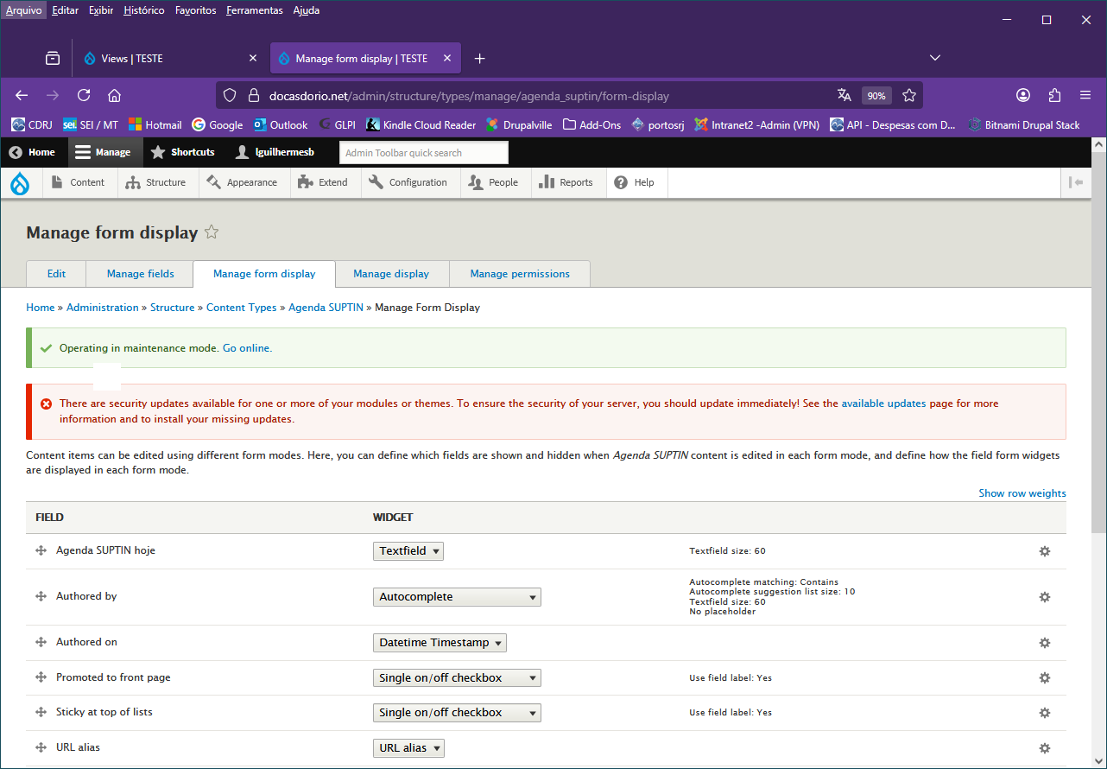

Próximo passo: Organizar os campos:
Arrastar pela cruz à esquerda do nome do campo, para a área “Disabled” os seguintes campos:

- Authored by
- Authored on
- Promoted to front page
- Sticky at the top of lists
- URL alias

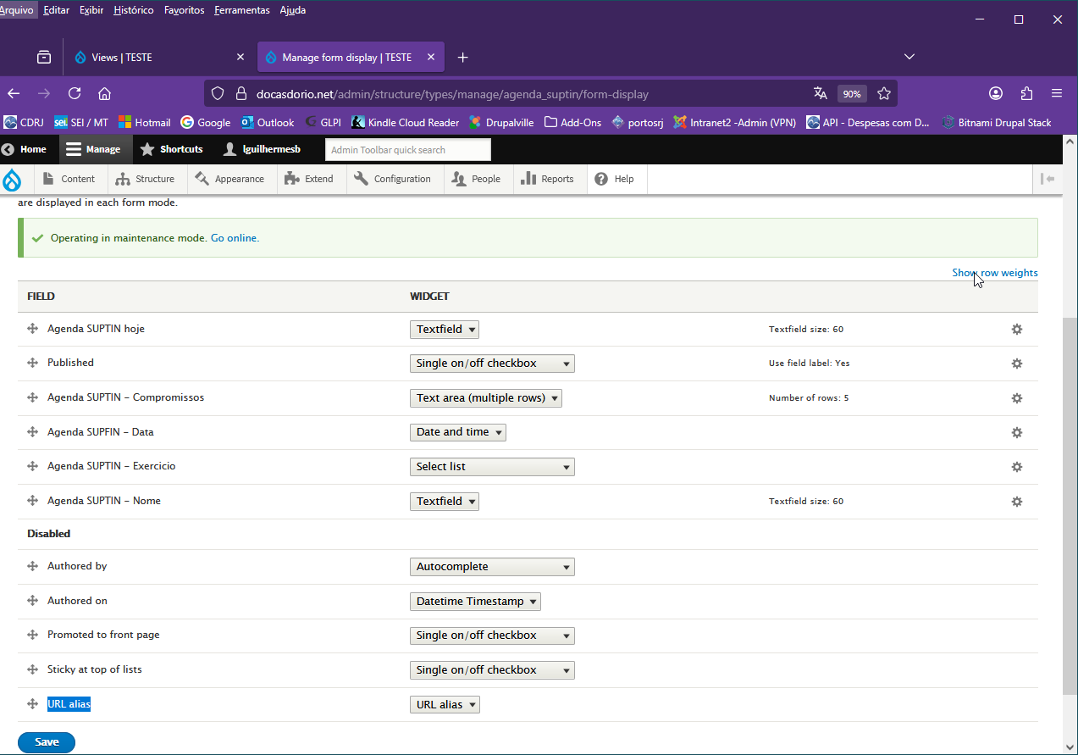

Reordenar os campos:
Arrastando pela cruz para cima ou para baixo para a seguinte ordem:

- Agenda SUPTIN hoje
- Agenda SUPTIN - Nome*
- Agenda SUPTIN - Exercicio*
- Agenda SUPFIN - Data*
- Agenda SUPTIN - Compromissos
- Published

Clique em ( Save )

WIDGET:
Agenda SUPTIN – Exercicio > Check box / Radio buttons
Clique em ( Save )

Proximo passo: Aba Manage display

Aba Manage display

(Antes de ordenar:)
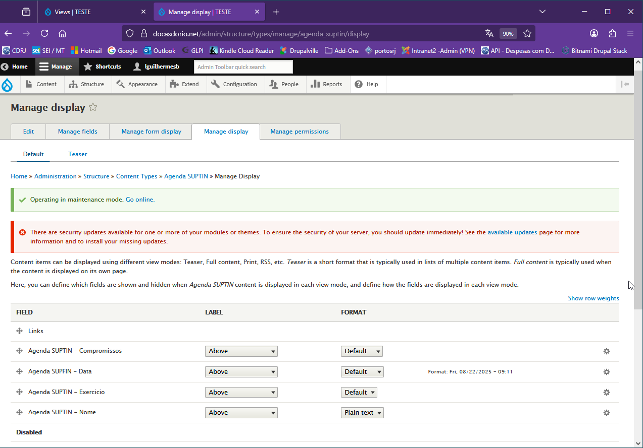

Reordenar os campos e ajustar o Label de cada campo (Above, Inline ou Hidden):

- Agenda SUPTIN - Nome*
- Agenda SUPTIN - Exercicio*
- Agenda SUPFIN - Data*
- Agenda SUPTIN – Compromissos
- Links

LABEL:

- Agenda SUPTIN - Nome* > Inline
- Agenda SUPTIN - Exercicio* > Inline
- Agenda SUPFIN - Data* > Inline
- Agenda SUPTIN – Compromissos > Above (Default)

Clique em ( Save )

Observação:
A versão do Drupal 9.5 e acima incluiu a aba Manage Permissions. Porém a versão atual do site é a 9.2 que não tem essa aba. As permissões deverão ser concedidas mais tarde em People > Roles > P_Agenda_SUPTIN após a criação deste grupo específico de usuários para editar a Agenda SUPTIN.

Próximo passo:
Criar o grupo de usuários (Perfil) P_Agenda_SUPTIN
Nota: o “P” significa Profile ou Perfil, ou ainda, Pessoas.
É apenas para não confundir com o nome do Tipo de conteúdo (Content Type) “Agenda SUPTIN”

Criar o grupo de usuários (Perfil) P_Agenda_SUPTIN

People > Roles > Add role
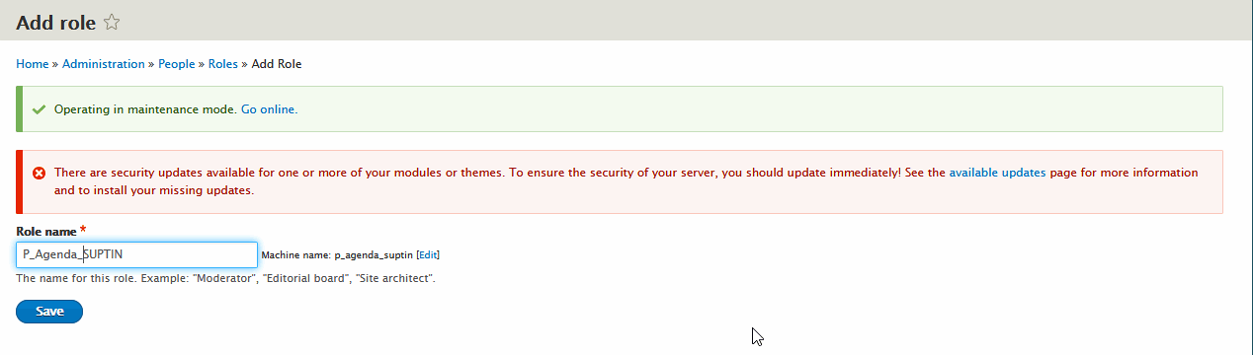
Clique Save

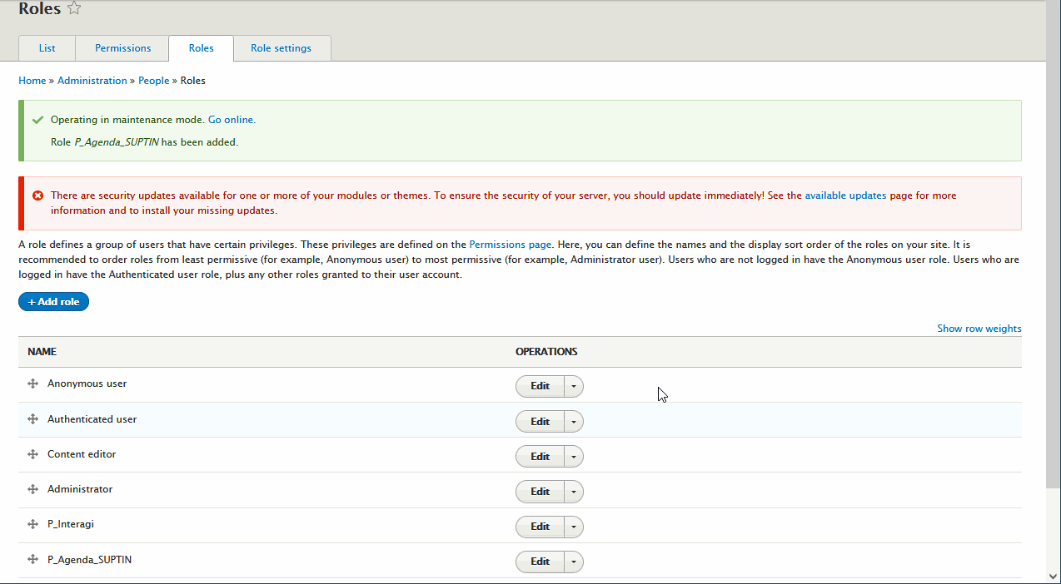

Próximo passo:
Atribuir as permissões ao grupo de usuários P_Agenda_SUPTIN:
Em  P_Agenda_SUPTIN clique na seta para baixo do botão Edit e clique em Edit Permissions

Observação:
Nas páginas seguir temos o Copy/paste da seção de permissões original, exibindo uma lista imensa de permissões para determinar quais delas poderão ser aplicadas ao perfil de editores da Agenda SUPTIN. A lista não está formatada, servindo apenas para se ter uma noção e poderá ser pulada diretamente para a página ___29_____ sem prejuizo de continuidade deste passo a passo.

Lista (não formatada) das permissões para o grupo P_Agenda_SUPTIN.

Permission | P_Agenda_SUPTIN
Admin Toolbar Search
Use Admin Toolbar search | P_Agenda_SUPTIN: Use Admin Toolbar search
All in One Accessibility
Add ADA Tool/Script all over the site  Warning: Give to trusted roles only; this permission has security implications. Users who have this permission can add and remove the ADA Tool/Script from the site. | P_Agenda_SUPTIN: Add ADA Tool/Script all over the site
Ban
Ban IP addresses | P_Agenda_SUPTIN: Ban IP addresses
Block
Administer blocks | P_Agenda_SUPTIN: Administer blocks
Book
Add content and child pages to books and manage their hierarchies. | P_Agenda_SUPTIN: Add content and child pages to books and manage their hierarchies.
Administer book outlines | P_Agenda_SUPTIN: Administer book outlines
Create new books | P_Agenda_SUPTIN: Create new books
View printer-friendly books  View a book page and all of its sub-pages as a single document for ease of printing. Can be performance heavy. | P_Agenda_SUPTIN: View printer-friendly books
Comment
Administer comment types and settings  Warning: Give to trusted roles only; this permission has security implications. | P_Agenda_SUPTIN: Administer comment types and settings
Administer comments and comment settings | P_Agenda_SUPTIN: Administer comments and comment settings
Edit own comments | P_Agenda_SUPTIN: Edit own comments
Post comments | P_Agenda_SUPTIN: Post comments
Skip comment approval | P_Agenda_SUPTIN: Skip comment approval
View comments | P_Agenda_SUPTIN: View comments
Configuration Manager
Export configuration  Warning: Give to trusted roles only; this permission has security implications. | P_Agenda_SUPTIN: Export configuration
Import configuration  Warning: Give to trusted roles only; this permission has security implications. | P_Agenda_SUPTIN: Import configuration
Synchronize configuration  Warning: Give to trusted roles only; this permission has security implications. | P_Agenda_SUPTIN: Synchronize configuration
Contact
Administer contact forms and contact form settings | P_Agenda_SUPTIN: Administer contact forms and contact form settings
Use the site-wide contact form | P_Agenda_SUPTIN: Use the site-wide contact form
Use users' personal contact forms | P_Agenda_SUPTIN: Use users' personal contact forms
Content Moderation
Editorial workflow: Use Archive transition.  Move content from Published state to Archived state. | P_Agenda_SUPTIN: Editorial workflow: Use Archive transition.
Editorial workflow: Use Create New Draft transition.  Move content from Draft, Published states to Draft state. | P_Agenda_SUPTIN: Editorial workflow: Use Create New Draft transition.
Editorial workflow: Use Publish transition.  Move content from Draft, Published states to Published state. | P_Agenda_SUPTIN: Editorial workflow: Use Publish transition.
Editorial workflow: Use Restore transition.  Move content from Archived state to Published state. | P_Agenda_SUPTIN: Editorial workflow: Use Restore transition.
Editorial workflow: Use Restore to Draft transition.  Move content from Archived state to Draft state. | P_Agenda_SUPTIN: Editorial workflow: Use Restore to Draft transition.
View any unpublished content | P_Agenda_SUPTIN: View any unpublished content
View the latest version  Requires the "View any unpublished content" or "View own unpublished content" permission | P_Agenda_SUPTIN: View the latest version
Contextual Links
Use contextual links | P_Agenda_SUPTIN: Use contextual links
Custom tokens
Administer custom token types  Create, edit and delete custom token types. | P_Agenda_SUPTIN: Administer custom token types
Administer custom tokens  Create, edit and delete custom tokens. | P_Agenda_SUPTIN: Administer custom tokens
Display Suite
Administer Display Suite  General permission for Display Suite settings pages. | P_Agenda_SUPTIN: Administer Display Suite
Administer classes  Manage classes. | P_Agenda_SUPTIN: Administer classes
Administer fields  Warning: Give to trusted roles only; this permission has security implications. Manage fields for every entity. | P_Agenda_SUPTIN: Administer fields
Display Suite Switch View Mode
Switch the view mode of any content type | P_Agenda_SUPTIN: Switch the view mode of any content type
Switch view modes on Administrador | P_Agenda_SUPTIN: Switch view modes on Administrador
Switch view modes on Agenda DIRAFI | P_Agenda_SUPTIN: Switch view modes on Agenda DIRAFI
Switch view modes on Agenda GERCOS | P_Agenda_SUPTIN: Switch view modes on Agenda GERCOS
Switch view modes on Agenda INTERAGI | P_Agenda_SUPTIN: Switch view modes on Agenda INTERAGI
Switch view modes on Agenda SUPTIN | P_Agenda_SUPTIN: Switch view modes on Agenda SUPTIN
Switch view modes on Article | P_Agenda_SUPTIN: Switch view modes on Article
Switch view modes on Basic page | P_Agenda_SUPTIN: Switch view modes on Basic page
Switch view modes on Book page | P_Agenda_SUPTIN: Switch view modes on Book page
Switch view modes on Conteúdo Institucional | P_Agenda_SUPTIN: Switch view modes on Conteúdo Institucional
Switch view modes on Hardware | P_Agenda_SUPTIN: Switch view modes on Hardware
Switch view modes on home | P_Agenda_SUPTIN: Switch view modes on home
Easy Breadcrumb
Administer Easy Breadcrumb settings | P_Agenda_SUPTIN: Administer Easy Breadcrumb settings
Email TFA
Administer Email TFA  Administer settings. | P_Agenda_SUPTIN: Administer Email TFA
Entity Export CSV
Administer Entity Export CSV | P_Agenda_SUPTIN: Administer Entity Export CSV
Use Entity Export CSV | P_Agenda_SUPTIN: Use Entity Export CSV
Entity Reference Revisions
Delete orphan revisions  Allow to access to the Entity Reference Revisions orphan deletion form. | P_Agenda_SUPTIN: Delete orphan revisions
Exclude Node Title
Administer exclude node title  Warning: Give to trusted roles only; this permission has security implications. | P_Agenda_SUPTIN: Administer exclude node title
Exclude any node title | P_Agenda_SUPTIN: Exclude any node title
Exclude own node title | P_Agenda_SUPTIN: Exclude own node title
Use exclude node title | P_Agenda_SUPTIN: Use exclude node title
External Links
Administer External Links  Warning: Give to trusted roles only; this permission has security implications. Administer External Links | P_Agenda_SUPTIN: Administer External Links
Field UI
Comment: Administer display | P_Agenda_SUPTIN: Comment: Administer display
Contact message: Administer display | P_Agenda_SUPTIN: Contact message: Administer display
Content: Administer display | P_Agenda_SUPTIN: Content: Administer display
Custom block: Administer display | P_Agenda_SUPTIN: Custom block: Administer display
Paragraph: Administer display | P_Agenda_SUPTIN: Paragraph: Administer display
Taxonomy term: Administer display | P_Agenda_SUPTIN: Taxonomy term: Administer display
User: Administer display | P_Agenda_SUPTIN: User: Administer display
Comment: Administer fields  Warning: Give to trusted roles only; this permission has security implications. | P_Agenda_SUPTIN: Comment: Administer fields
Contact message: Administer fields  Warning: Give to trusted roles only; this permission has security implications. | P_Agenda_SUPTIN: Contact message: Administer fields
Content: Administer fields  Warning: Give to trusted roles only; this permission has security implications. | P_Agenda_SUPTIN: Content: Administer fields
Custom block: Administer fields  Warning: Give to trusted roles only; this permission has security implications. | P_Agenda_SUPTIN: Custom block: Administer fields
Paragraph: Administer fields  Warning: Give to trusted roles only; this permission has security implications. | P_Agenda_SUPTIN: Paragraph: Administer fields
Taxonomy term: Administer fields  Warning: Give to trusted roles only; this permission has security implications. | P_Agenda_SUPTIN: Taxonomy term: Administer fields
User: Administer fields  Warning: Give to trusted roles only; this permission has security implications. | P_Agenda_SUPTIN: User: Administer fields
Comment: Administer form display | P_Agenda_SUPTIN: Comment: Administer form display
Contact message: Administer form display | P_Agenda_SUPTIN: Contact message: Administer form display
Content: Administer form display | P_Agenda_SUPTIN: Content: Administer form display
Custom block: Administer form display | P_Agenda_SUPTIN: Custom block: Administer form display
Paragraph: Administer form display | P_Agenda_SUPTIN: Paragraph: Administer form display
Taxonomy term: Administer form display | P_Agenda_SUPTIN: Taxonomy term: Administer form display
User: Administer form display | P_Agenda_SUPTIN: User: Administer form display
Add, edit, and delete custom display modes. | P_Agenda_SUPTIN: Add, edit, and delete custom display modes.
File
Access the Files overview page | P_Agenda_SUPTIN: Access the Files overview page
Filter
Administer text formats and filters  Warning: Give to trusted roles only; this permission has security implications. Define how text is handled by combining filters into text formats. | P_Agenda_SUPTIN: Administer text formats and filters
Use the Basic HTML text format  Warning: This permission may have security implications depending on how the text format is configured. | P_Agenda_SUPTIN: Use the Basic HTML text format
Use the Full HTML text format  Warning: This permission may have security implications depending on how the text format is configured. | P_Agenda_SUPTIN: Use the Full HTML text format
Use the CK4 Full HTML text format  Warning: This permission may have security implications depending on how the text format is configured. | P_Agenda_SUPTIN: Use the CK4 Full HTML text format
Use the Restricted HTML text format  Warning: This permission may have security implications depending on how the text format is configured. | P_Agenda_SUPTIN: Use the Restricted HTML text format
Font Awesome
Access fontawesome additional settings  Grants access to the additional settings in fontawesome fields type. Without this permission, only the icon can be selected. | P_Agenda_SUPTIN: Access fontawesome additional settings
Image
Administer image styles | P_Agenda_SUPTIN: Administer image styles
Imce File Manager
Administer Imce File Manager  Warning: Give to trusted roles only; this permission has security implications. | P_Agenda_SUPTIN: Administer Imce File Manager
Layout Builder
Configure any layout  Warning: Give to trusted roles only; this permission has security implications. | P_Agenda_SUPTIN: Configure any layout
Create and edit custom blocks  Manage the single-use blocks within the Layout Builder | P_Agenda_SUPTIN: Create and edit custom blocks
Mask Field
Administer Mask Field module  Warning: Give to trusted roles only; this permission has security implications. Allows to view and edit Mask Field module settings. | P_Agenda_SUPTIN: Administer Mask Field module
Masquerade
Masquerade as Administrator  Warning: Give to trusted roles only; this permission has security implications. | P_Agenda_SUPTIN: Masquerade as Administrator
Masquerade as Authenticated user  Warning: Give to trusted roles only; this permission has security implications. | P_Agenda_SUPTIN: Masquerade as Authenticated user
Masquerade as Content editor  Warning: Give to trusted roles only; this permission has security implications. | P_Agenda_SUPTIN: Masquerade as Content editor
Masquerade as P_Agenda_SUPTIN  Warning: Give to trusted roles only; this permission has security implications. | P_Agenda_SUPTIN: Masquerade as P_Agenda_SUPTIN
Masquerade as P_Interagi  Warning: Give to trusted roles only; this permission has security implications. | P_Agenda_SUPTIN: Masquerade as P_Interagi
Masquerade as any user except super user  Warning: Give to trusted roles only; this permission has security implications. | P_Agenda_SUPTIN: Masquerade as any user except super user
Masquerade as super user (UID 1)  Warning: Give to trusted roles only; this permission has security implications. | P_Agenda_SUPTIN: Masquerade as super user (UID 1)
Metatag
Administer meta tags  Warning: Give to trusted roles only; this permission has security implications. Control the main settings pages and modify per-object meta tags. | P_Agenda_SUPTIN: Administer meta tags
Node
Administrador: Create new content | P_Agenda_SUPTIN: Administrador: Create new content
Agenda DIRAFI: Create new content | P_Agenda_SUPTIN: Agenda DIRAFI: Create new content
Agenda GERCOS: Create new content | P_Agenda_SUPTIN: Agenda GERCOS: Create new content
Agenda INTERAGI: Create new content | P_Agenda_SUPTIN: Agenda INTERAGI: Create new content
Agenda SUPTIN: Create new content | P_Agenda_SUPTIN: Agenda SUPTIN: Create new content
Article: Create new content | P_Agenda_SUPTIN: Article: Create new content
Basic page: Create new content | P_Agenda_SUPTIN: Basic page: Create new content
Book page: Create new content | P_Agenda_SUPTIN: Book page: Create new content
Conteúdo Institucional: Create new content | P_Agenda_SUPTIN: Conteúdo Institucional: Create new content
Hardware: Create new content | P_Agenda_SUPTIN: Hardware: Create new content
home: Create new content | P_Agenda_SUPTIN: home: Create new content
Administrador: Delete any content | P_Agenda_SUPTIN: Administrador: Delete any content
Agenda DIRAFI: Delete any content | P_Agenda_SUPTIN: Agenda DIRAFI: Delete any content
Agenda GERCOS: Delete any content | P_Agenda_SUPTIN: Agenda GERCOS: Delete any content
Agenda INTERAGI: Delete any content | P_Agenda_SUPTIN: Agenda INTERAGI: Delete any content
Agenda SUPTIN: Delete any content | P_Agenda_SUPTIN: Agenda SUPTIN: Delete any content
Article: Delete any content | P_Agenda_SUPTIN: Article: Delete any content
Basic page: Delete any content | P_Agenda_SUPTIN: Basic page: Delete any content
Book page: Delete any content | P_Agenda_SUPTIN: Book page: Delete any content
Conteúdo Institucional: Delete any content | P_Agenda_SUPTIN: Conteúdo Institucional: Delete any content
Hardware: Delete any content | P_Agenda_SUPTIN: Hardware: Delete any content
home: Delete any content | P_Agenda_SUPTIN: home: Delete any content
Administrador: Delete own content  Note that anonymous users with this permission are able to delete any content created by any anonymous user. | P_Agenda_SUPTIN: Administrador: Delete own content
Agenda DIRAFI: Delete own content  Note that anonymous users with this permission are able to delete any content created by any anonymous user. | P_Agenda_SUPTIN: Agenda DIRAFI: Delete own content
Agenda GERCOS: Delete own content  Note that anonymous users with this permission are able to delete any content created by any anonymous user. | P_Agenda_SUPTIN: Agenda GERCOS: Delete own content
Agenda INTERAGI: Delete own content  Note that anonymous users with this permission are able to delete any content created by any anonymous user. | P_Agenda_SUPTIN: Agenda INTERAGI: Delete own content
Agenda SUPTIN: Delete own content  Note that anonymous users with this permission are able to delete any content created by any anonymous user. | P_Agenda_SUPTIN: Agenda SUPTIN: Delete own content
Article: Delete own content  Note that anonymous users with this permission are able to delete any content created by any anonymous user. | P_Agenda_SUPTIN: Article: Delete own content
Basic page: Delete own content  Note that anonymous users with this permission are able to delete any content created by any anonymous user. | P_Agenda_SUPTIN: Basic page: Delete own content
Book page: Delete own content  Note that anonymous users with this permission are able to delete any content created by any anonymous user. | P_Agenda_SUPTIN: Book page: Delete own content
Conteúdo Institucional: Delete own content  Note that anonymous users with this permission are able to delete any content created by any anonymous user. | P_Agenda_SUPTIN: Conteúdo Institucional: Delete own content
Hardware: Delete own content  Note that anonymous users with this permission are able to delete any content created by any anonymous user. | P_Agenda_SUPTIN: Hardware: Delete own content
home: Delete own content  Note that anonymous users with this permission are able to delete any content created by any anonymous user. | P_Agenda_SUPTIN: home: Delete own content
Administrador: Delete revisions  To delete a revision, you also need permission to delete the content item. | P_Agenda_SUPTIN: Administrador: Delete revisions
Agenda DIRAFI: Delete revisions  To delete a revision, you also need permission to delete the content item. | P_Agenda_SUPTIN: Agenda DIRAFI: Delete revisions
Agenda GERCOS: Delete revisions  To delete a revision, you also need permission to delete the content item. | P_Agenda_SUPTIN: Agenda GERCOS: Delete revisions
Agenda INTERAGI: Delete revisions  To delete a revision, you also need permission to delete the content item. | P_Agenda_SUPTIN: Agenda INTERAGI: Delete revisions
Agenda SUPTIN: Delete revisions  To delete a revision, you also need permission to delete the content item. | P_Agenda_SUPTIN: Agenda SUPTIN: Delete revisions
Article: Delete revisions  To delete a revision, you also need permission to delete the content item. | P_Agenda_SUPTIN: Article: Delete revisions
Basic page: Delete revisions  To delete a revision, you also need permission to delete the content item. | P_Agenda_SUPTIN: Basic page: Delete revisions
Book page: Delete revisions  To delete a revision, you also need permission to delete the content item. | P_Agenda_SUPTIN: Book page: Delete revisions
Conteúdo Institucional: Delete revisions  To delete a revision, you also need permission to delete the content item. | P_Agenda_SUPTIN: Conteúdo Institucional: Delete revisions
Hardware: Delete revisions  To delete a revision, you also need permission to delete the content item. | P_Agenda_SUPTIN: Hardware: Delete revisions
home: Delete revisions  To delete a revision, you also need permission to delete the content item. | P_Agenda_SUPTIN: home: Delete revisions
Administrador: Edit any content | P_Agenda_SUPTIN: Administrador: Edit any content
Agenda DIRAFI: Edit any content | P_Agenda_SUPTIN: Agenda DIRAFI: Edit any content
Agenda GERCOS: Edit any content | P_Agenda_SUPTIN: Agenda GERCOS: Edit any content
Agenda INTERAGI: Edit any content | P_Agenda_SUPTIN: Agenda INTERAGI: Edit any content
Agenda SUPTIN: Edit any content | P_Agenda_SUPTIN: Agenda SUPTIN: Edit any content
Article: Edit any content | P_Agenda_SUPTIN: Article: Edit any content
Basic page: Edit any content | P_Agenda_SUPTIN: Basic page: Edit any content
Book page: Edit any content | P_Agenda_SUPTIN: Book page: Edit any content
Conteúdo Institucional: Edit any content | P_Agenda_SUPTIN: Conteúdo Institucional: Edit any content
Hardware: Edit any content | P_Agenda_SUPTIN: Hardware: Edit any content
home: Edit any content | P_Agenda_SUPTIN: home: Edit any content
Administrador: Edit own content  Note that anonymous users with this permission are able to edit any content created by any anonymous user. | P_Agenda_SUPTIN: Administrador: Edit own content
Agenda DIRAFI: Edit own content  Note that anonymous users with this permission are able to edit any content created by any anonymous user. | P_Agenda_SUPTIN: Agenda DIRAFI: Edit own content
Agenda GERCOS: Edit own content  Note that anonymous users with this permission are able to edit any content created by any anonymous user. | P_Agenda_SUPTIN: Agenda GERCOS: Edit own content
Agenda INTERAGI: Edit own content  Note that anonymous users with this permission are able to edit any content created by any anonymous user. | P_Agenda_SUPTIN: Agenda INTERAGI: Edit own content
Agenda SUPTIN: Edit own content  Note that anonymous users with this permission are able to edit any content created by any anonymous user. | P_Agenda_SUPTIN: Agenda SUPTIN: Edit own content
Article: Edit own content  Note that anonymous users with this permission are able to edit any content created by any anonymous user. | P_Agenda_SUPTIN: Article: Edit own content
Basic page: Edit own content  Note that anonymous users with this permission are able to edit any content created by any anonymous user. | P_Agenda_SUPTIN: Basic page: Edit own content
Book page: Edit own content  Note that anonymous users with this permission are able to edit any content created by any anonymous user. | P_Agenda_SUPTIN: Book page: Edit own content
Conteúdo Institucional: Edit own content  Note that anonymous users with this permission are able to edit any content created by any anonymous user. | P_Agenda_SUPTIN: Conteúdo Institucional: Edit own content
Hardware: Edit own content  Note that anonymous users with this permission are able to edit any content created by any anonymous user. | P_Agenda_SUPTIN: Hardware: Edit own content
home: Edit own content  Note that anonymous users with this permission are able to edit any content created by any anonymous user. | P_Agenda_SUPTIN: home: Edit own content
Administrador: Revert revisions  To revert a revision, you also need permission to edit the content item. | P_Agenda_SUPTIN: Administrador: Revert revisions
Agenda DIRAFI: Revert revisions  To revert a revision, you also need permission to edit the content item. | P_Agenda_SUPTIN: Agenda DIRAFI: Revert revisions
Agenda GERCOS: Revert revisions  To revert a revision, you also need permission to edit the content item. | P_Agenda_SUPTIN: Agenda GERCOS: Revert revisions
Agenda INTERAGI: Revert revisions  To revert a revision, you also need permission to edit the content item. | P_Agenda_SUPTIN: Agenda INTERAGI: Revert revisions
Agenda SUPTIN: Revert revisions  To revert a revision, you also need permission to edit the content item. | P_Agenda_SUPTIN: Agenda SUPTIN: Revert revisions
Article: Revert revisions  To revert a revision, you also need permission to edit the content item. | P_Agenda_SUPTIN: Article: Revert revisions
Basic page: Revert revisions  To revert a revision, you also need permission to edit the content item. | P_Agenda_SUPTIN: Basic page: Revert revisions
Book page: Revert revisions  To revert a revision, you also need permission to edit the content item. | P_Agenda_SUPTIN: Book page: Revert revisions
Conteúdo Institucional: Revert revisions  To revert a revision, you also need permission to edit the content item. | P_Agenda_SUPTIN: Conteúdo Institucional: Revert revisions
Hardware: Revert revisions  To revert a revision, you also need permission to edit the content item. | P_Agenda_SUPTIN: Hardware: Revert revisions
home: Revert revisions  To revert a revision, you also need permission to edit the content item. | P_Agenda_SUPTIN: home: Revert revisions
Administrador: View revisions  To view a revision, you also need permission to view the content item. | P_Agenda_SUPTIN: Administrador: View revisions
Agenda DIRAFI: View revisions  To view a revision, you also need permission to view the content item. | P_Agenda_SUPTIN: Agenda DIRAFI: View revisions
Agenda GERCOS: View revisions  To view a revision, you also need permission to view the content item. | P_Agenda_SUPTIN: Agenda GERCOS: View revisions
Agenda INTERAGI: View revisions  To view a revision, you also need permission to view the content item. | P_Agenda_SUPTIN: Agenda INTERAGI: View revisions
Agenda SUPTIN: View revisions  To view a revision, you also need permission to view the content item. | P_Agenda_SUPTIN: Agenda SUPTIN: View revisions
Article: View revisions  To view a revision, you also need permission to view the content item. | P_Agenda_SUPTIN: Article: View revisions
Basic page: View revisions  To view a revision, you also need permission to view the content item. | P_Agenda_SUPTIN: Basic page: View revisions
Book page: View revisions  To view a revision, you also need permission to view the content item. | P_Agenda_SUPTIN: Book page: View revisions
Conteúdo Institucional: View revisions  To view a revision, you also need permission to view the content item. | P_Agenda_SUPTIN: Conteúdo Institucional: View revisions
Hardware: View revisions  To view a revision, you also need permission to view the content item. | P_Agenda_SUPTIN: Hardware: View revisions
home: View revisions  To view a revision, you also need permission to view the content item. | P_Agenda_SUPTIN: home: View revisions
Access the Content overview page | P_Agenda_SUPTIN: Access the Content overview page
Administer content  Warning: Give to trusted roles only; this permission has security implications. Promote, change ownership, edit revisions, and perform other tasks across all content types. | P_Agenda_SUPTIN: Administer content
Administer content types  Warning: Give to trusted roles only; this permission has security implications. Maintain the types of content available and the fields that are associated with those types. | P_Agenda_SUPTIN: Administer content types
Bypass content access control  Warning: Give to trusted roles only; this permission has security implications. View, edit and delete all content regardless of permission restrictions. | P_Agenda_SUPTIN: Bypass content access control
Delete all revisions  To delete a revision, you also need permission to delete the content item. | P_Agenda_SUPTIN: Delete all revisions
Revert all revisions  To revert a revision, you also need permission to edit the content item. | P_Agenda_SUPTIN: Revert all revisions
View all revisions  To view a revision, you also need permission to view the content item. | P_Agenda_SUPTIN: View all revisions
View published content | P_Agenda_SUPTIN: View published content
View own unpublished content | P_Agenda_SUPTIN: View own unpublished content
Page Manager
Administer pages | P_Agenda_SUPTIN: Administer pages
Panels
Administer Panels layouts  Allows a user to administer exported Panels layout plugins & instances. | P_Agenda_SUPTIN: Administer Panels layouts
Administer Panels styles  Allows a user to administer the styles of Panel panes. | P_Agenda_SUPTIN: Administer Panels styles
Configure access settings on Panel panes  Access rules (often also called visibility rules) can be configured on a per-pane basis. This permission allows users to configure those settings. | P_Agenda_SUPTIN: Configure access settings on Panel panes
Configure advanced settings on Panel panes | P_Agenda_SUPTIN: Configure advanced settings on Panel panes
Configure caching settings on Panels  Allows a user to configure caching on Panels displays and panes. | P_Agenda_SUPTIN: Configure caching settings on Panels
Use Panels Dashboard  Allows a user to access the Panels Dashboard. | P_Agenda_SUPTIN: Use Panels Dashboard
Use panel locks  Allows a user to lock and unlock panes in a panel display. | P_Agenda_SUPTIN: Use panel locks
Use the Panels In-Place Editor with Page Manager  Allows users with access to the In-Place editor to administer page manager pages. This permission is only needed for users without "use page manager" access. | P_Agenda_SUPTIN: Use the Panels In-Place Editor with Page Manager
View administrative links on Panel panes | P_Agenda_SUPTIN: View administrative links on Panel panes
Panels IPE
Access panels in-place editing | P_Agenda_SUPTIN: Access panels in-place editing
Paragraphs
Administer Paragraphs settings  Administer Paragraphs settings | P_Agenda_SUPTIN: Administer Paragraphs settings
Administer Paragraphs types  Allow to define the existing Paragraphs types and their Fields | P_Agenda_SUPTIN: Administer Paragraphs types
Edit behavior plugin settings  Users with this permission can edit behavior plugin settings on Paragraphs behavior instance | P_Agenda_SUPTIN: Edit behavior plugin settings
View unpublished paragraphs  Users with this permission can view paragraphs that are unpublished | P_Agenda_SUPTIN: View unpublished paragraphs
Paragraphs Type Permissions
Bypass Paragraphs type content access control  Is able to administer content for all Paragraph types | P_Agenda_SUPTIN: Bypass Paragraphs type content access control
Path
Administer URL aliases | P_Agenda_SUPTIN: Administer URL aliases
Create and edit URL aliases | P_Agenda_SUPTIN: Create and edit URL aliases
Pathauto
Administer pathauto  Allows a user to configure patterns for automated aliases and bulk delete URL-aliases. | P_Agenda_SUPTIN: Administer pathauto
Notify of Path Changes  Determines whether or not users are notified. | P_Agenda_SUPTIN: Notify of Path Changes
Quick Edit
Access in-place editing | P_Agenda_SUPTIN: Access in-place editing
RESTful Web Services
Administer REST resource configuration | P_Agenda_SUPTIN: Administer REST resource configuration
Search
Administer search | P_Agenda_SUPTIN: Administer search
Use advanced search | P_Agenda_SUPTIN: Use advanced search
Use search | P_Agenda_SUPTIN: Use search
Shortcut
Administer shortcuts | P_Agenda_SUPTIN: Administer shortcuts
Edit current shortcut set  Editing the current shortcut set will affect other users if that set has been assigned to or selected by other users. Granting "Select any shortcut set" permission along with this permission will grant permission to edit any shortcut set. | P_Agenda_SUPTIN: Edit current shortcut set
Select any shortcut set  From all shortcut sets, select one to be own active set. Without this permission, an administrator selects shortcut sets for users. | P_Agenda_SUPTIN: Select any shortcut set
Use shortcuts | P_Agenda_SUPTIN: Use shortcuts
Sitemap
Administer sitemap  Change what is displayed on the sitemap. | P_Agenda_SUPTIN: Administer sitemap
Choose whether to show disabled menu items on the sitemap  Warning: Give to trusted roles only; this permission has security implications. Choose whether or not to show disabled menu links to users with the 'View published sitemap' permission. Disabled menu links reveal information that would normally require the 'Administer menus and menu links' permission. | P_Agenda_SUPTIN: Choose whether to show disabled menu items on the sitemap
Choose whether to show unpublished taxonomy terms on the sitemap  Warning: Give to trusted roles only; this permission has security implications. Choose whether or not to show unpublished taxonomy terms to users with the 'View published sitemap' permission. Unpublished taxonomy terms reveal information that would normally require the 'Administer vocabularies and terms' permission. | P_Agenda_SUPTIN: Choose whether to show unpublished taxonomy terms on the sitemap
Set front page RSS link on sitemap  Warning: Give to trusted roles only; this permission has security implications. Link to external sites, and bypass access checking when linking to internal paths. | P_Agenda_SUPTIN: Set front page RSS link on sitemap
View published sitemap | P_Agenda_SUPTIN: View published sitemap
SpeakEasy
Access SpeakEasy settings  Allow users to configure SpeakEasy block settings. | P_Agenda_SUPTIN: Access SpeakEasy settings
System
Administer menus and menu links | P_Agenda_SUPTIN: Administer menus and menu links
Administer modules | P_Agenda_SUPTIN: Administer modules
Administer site configuration  Warning: Give to trusted roles only; this permission has security implications. | P_Agenda_SUPTIN: Administer site configuration
Administer software updates  Warning: Give to trusted roles only; this permission has security implications. | P_Agenda_SUPTIN: Administer software updates
Administer themes | P_Agenda_SUPTIN: Administer themes
Link to any page  Warning: Give to trusted roles only; this permission has security implications. This allows to bypass access checking when linking to internal paths. | P_Agenda_SUPTIN: Link to any page
Use the administration pages and help | P_Agenda_SUPTIN: Use the administration pages and help
Use the site in maintenance mode | P_Agenda_SUPTIN: Use the site in maintenance mode
View site reports  Warning: Give to trusted roles only; this permission has security implications. | P_Agenda_SUPTIN: View site reports
View the administration theme  This is only used when the site is configured to use a separate administration theme on the Appearance page. | P_Agenda_SUPTIN: View the administration theme
Taxonomy
Tags: Create terms | P_Agenda_SUPTIN: Tags: Create terms
Tags: Delete terms | P_Agenda_SUPTIN: Tags: Delete terms
Tags: Edit terms | P_Agenda_SUPTIN: Tags: Edit terms
Access the taxonomy vocabulary overview page  Get an overview of all taxonomy vocabularies. | P_Agenda_SUPTIN: Access the taxonomy vocabulary overview page
Administer vocabularies and terms | P_Agenda_SUPTIN: Administer vocabularies and terms
Toolbar
Use the toolbar | P_Agenda_SUPTIN: Use the toolbar
Tour
Access tours | P_Agenda_SUPTIN: Access tours
Update Manager
View update notifications  These messages are displayed on most administrative pages when updates become available. | P_Agenda_SUPTIN: View update notifications
User
Administer account settings  Warning: Give to trusted roles only; this permission has security implications. Configure site-wide settings and behavior for user accounts and registration. This includes account cancellation methods, the content of user emails and fields attached to users. | P_Agenda_SUPTIN: Administer account settings
Administer roles and permissions  Warning: Give to trusted roles only; this permission has security implications. | P_Agenda_SUPTIN: Administer roles and permissions
Administer users  Warning: Give to trusted roles only; this permission has security implications. Manage all user accounts. This includes editing all user information, changes of email addresses and passwords, issuing emails to users and blocking and deleting user accounts. | P_Agenda_SUPTIN: Administer users
Cancel own user account  Note: content may be kept, unpublished, deleted or transferred to the anonymous user depending on the configured user settings. | P_Agenda_SUPTIN: Cancel own user account
Change own username | P_Agenda_SUPTIN: Change own username
Select method for cancelling account  Warning: Give to trusted roles only; this permission has security implications. | P_Agenda_SUPTIN: Select method for cancelling account
View user email addresses  Users without this permission will not have access to email addresses on user pages or other places where they might be shown, such as Views and JSON:API responses. | P_Agenda_SUPTIN: View user email addresses
View user information | P_Agenda_SUPTIN: View user information
Views UI
Administer views  Warning: Give to trusted roles only; this permission has security implications. | P_Agenda_SUPTIN: Administer views
Workflows
Administer workflows  Warning: Give to trusted roles only; this permission has security implications. Create and edit workflows. | P_Agenda_SUPTIN: Administer workflows

Atribuir as permissões ao grupo de usuários P_Agenda_SUPTIN:
Em Edit Role (Editar regra) , marcar na checkbox correspondente as seguintes permissões desejadas para o perfil do grupo dos usuários da Agenda SUPTIN. Caso a regra não exista, será necessário instalar o módulo correspondente.

Admin Toolbar Search
Use Admin Toolbar search

CKEditor Upload Image *
Use the CKEditor Upload Image
Warning: Give to trusted roles only; this permission has security implications.

Display Suite Switch View Mode
Switch view modes on Agenda SUPTIN

Entity Export CSV
Use Entity Export CSV

File
Access the Files overview page

Node
Agenda SUPTIN: Create new content
Agenda SUPTIN: Delete any content
Agenda SUPTIN: Delete own content
Agenda SUPTIN: Delete revisions
To delete a revision, you also need permission to delete the content item
Agenda SUPTIN: Edit any content
Agenda SUPTIN: Edit own content
Agenda SUPTIN: Revert revisions
To revert a revision, you also need permission to edit the content item.
Agenda SUPTIN: View revisions
To view a revision, you also need permission to view the content item.
Access the Content overview page
View all revisions
To view a revision, you also need permission to view the content item.
View published content
View own unpublished content

Publish Content (*) Precisa do módulo _________________________
Agenda_suptin: publish any node type
Agenda_suptin: publish editable node type
Agenda_suptin: publish own node type
Agenda_suptin: unpublish any node type
Agenda_suptin: unpublish editable node type
Agenda_suptin: unpublish own node type

Search
Use advanced search
Use search

Toolbar
Use the toolbar

View Unpublished (*) Precisa do módulo _________________________
Agenda SUPTIN: View any unpublished content

Clique em [ Save Permissions ] no final da lista

Próximo passo: inserir um usuário no grupo P_Agenda_SUPTIN e testar a edição de conteúdo da Agenda
Criar o usuário user.teste e inserir no perfil de editores da Agenda SUPTN cujas regras (roles) foram determinadas.

Clicar em [ Create new account ] ou ir para
People > Add User

- username: user.teste
- password: *******
- Status: active
- Roles (perfil) ☑ P_Agenda_SUPTIN
- Time zone: Sao Paulo (default é UTC)

Clique [Save]
A tela retorna para a lista de usuários

Nota: a página contendo a View da agenda ainda não foi montada, porém o usuário já consegue preencher o formulário do conteúdo Agenda SUPTIN criado anteriormente.

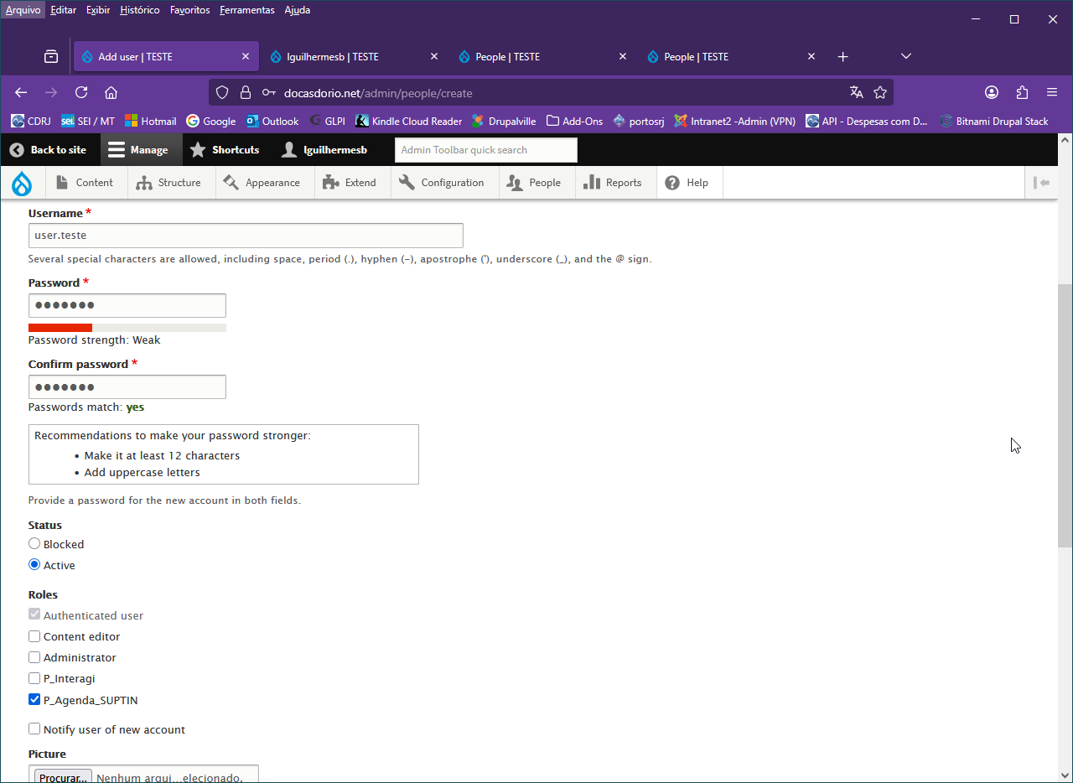
A tela irá retornar para Add user, pois poderão haver outros usuários a serem cadastrados. Como este não é o caso,

Testando o preenchimento do formulario pelo usuário:
Para testar o que o usuário (que acaba de ser criado com senha provisoria), pode fazer, basta fazer o login como ele. Se se trata de um usuário real, ja existente, use um usuário de teste iserindo ele no mesmo grupo do usuario real e faça o login como ele.

Outra forma de fazer isso (verificar as autorizações de um usuário real) é usar o módulo Masquerade. Como o nome diz, o administrador coloca a “máscara” do usuario que deseja testar sem necessiddade da senha dele e procede aos testes. Depois basta tirar a máscara (Unmasquerade) e voltar a ser o administrador.

Clicar em Pessoas (People) no menu do Administrador

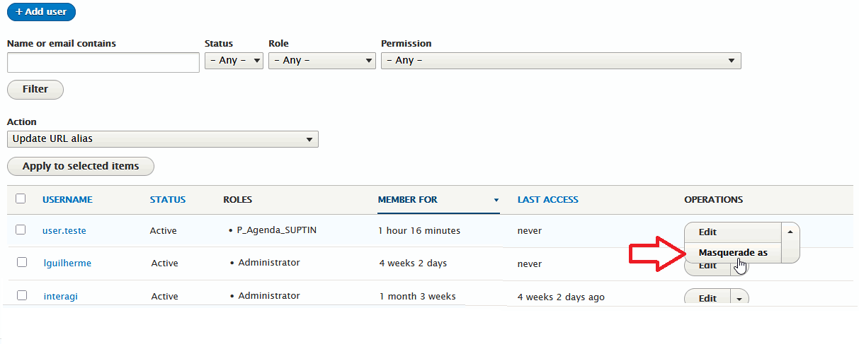

Administrador usando a “máscara” do usuário user.teste
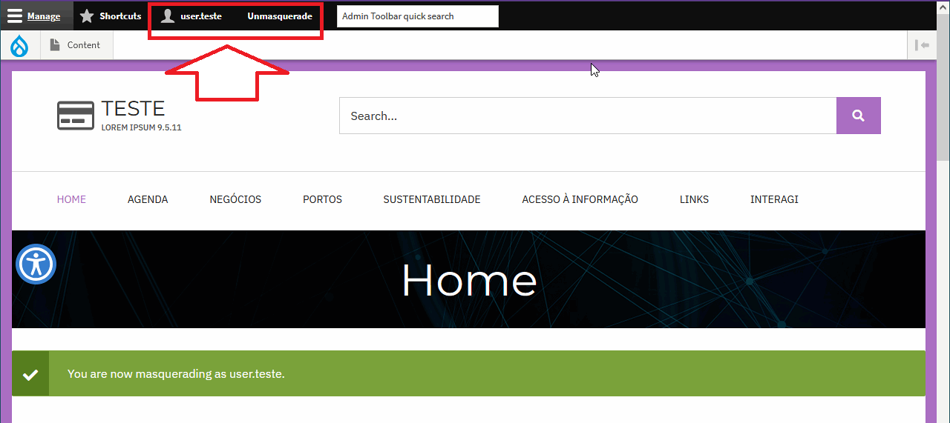

user.teste criando novo conteudo para a Agenda SUPTIN:
Mais tarde. Após a criação da View desta agenda, veremos um método bem simples de inserir conteúdo em um dia desejado.
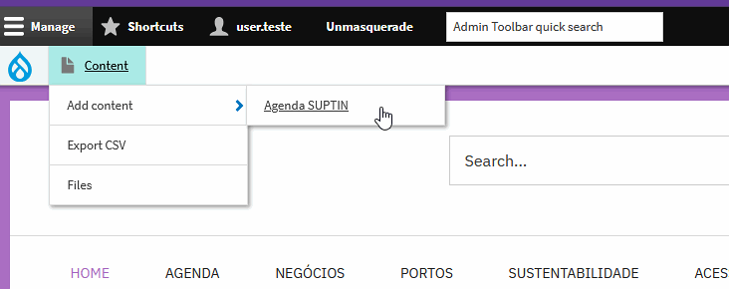

Formuário para preenchimento do conteúdo criado para a Agenda SUPTIN
No caso, o compromisso da SUPTIN para um determinado dia a ser escolhido.
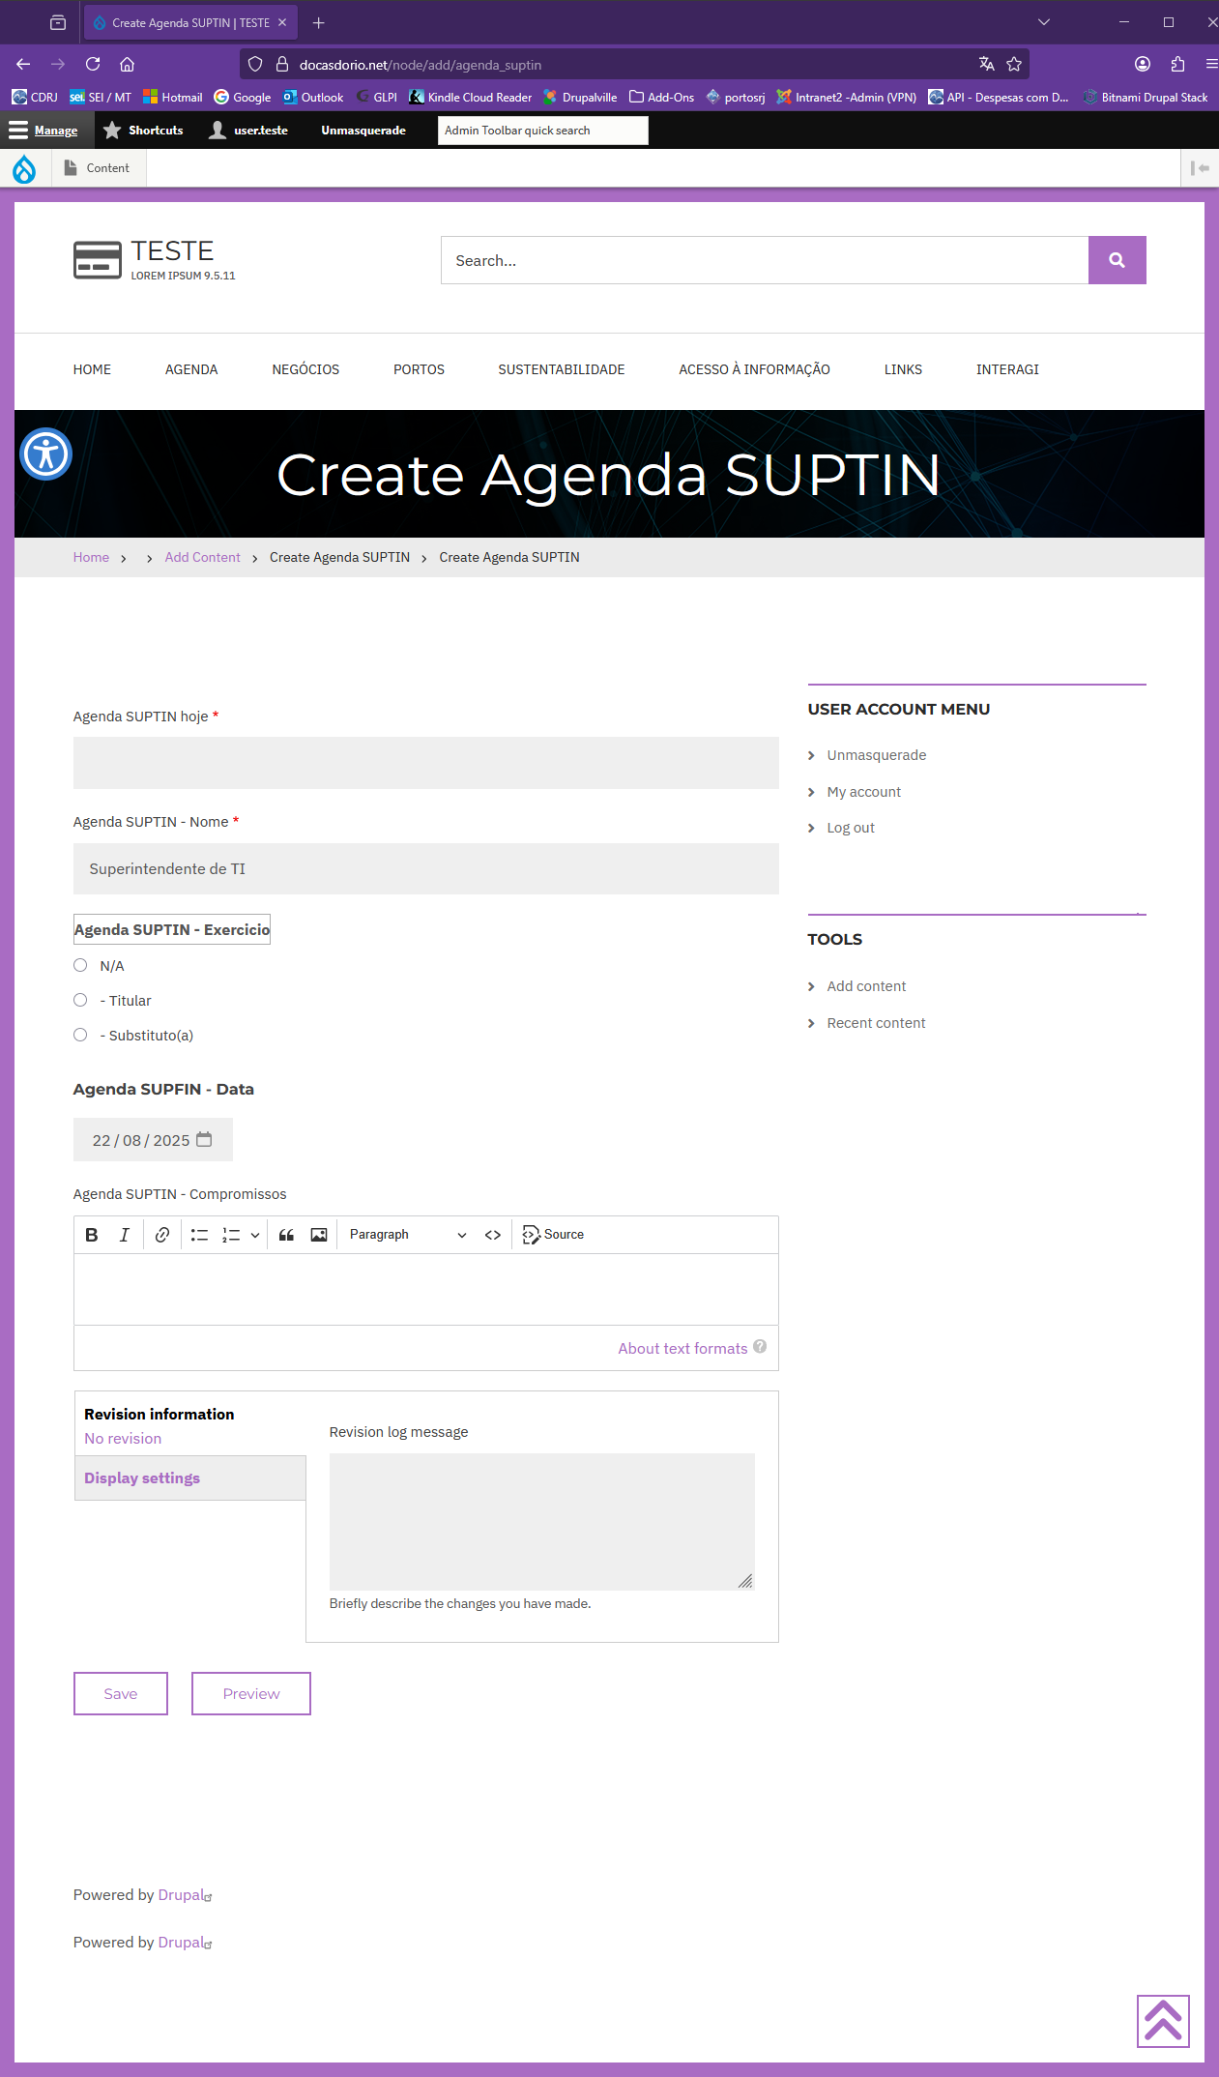
Caso precise alterar o formulário, vá para: Structure > Content Types > Agenda SUPTIN > ABA Manage Form Display

Formulário preenchido com um compromisso no dia 22/08/2025
Clique em [ Save ] no final da página para salvar o compromisso.
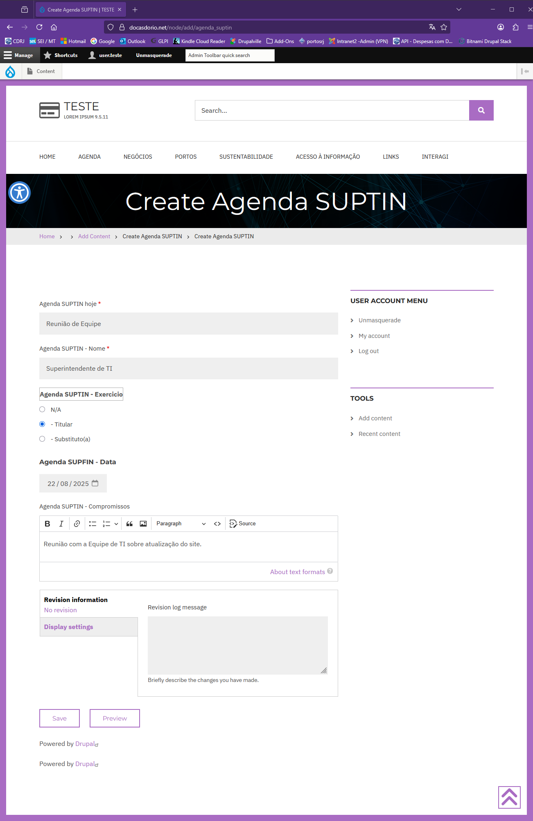

Resultado:
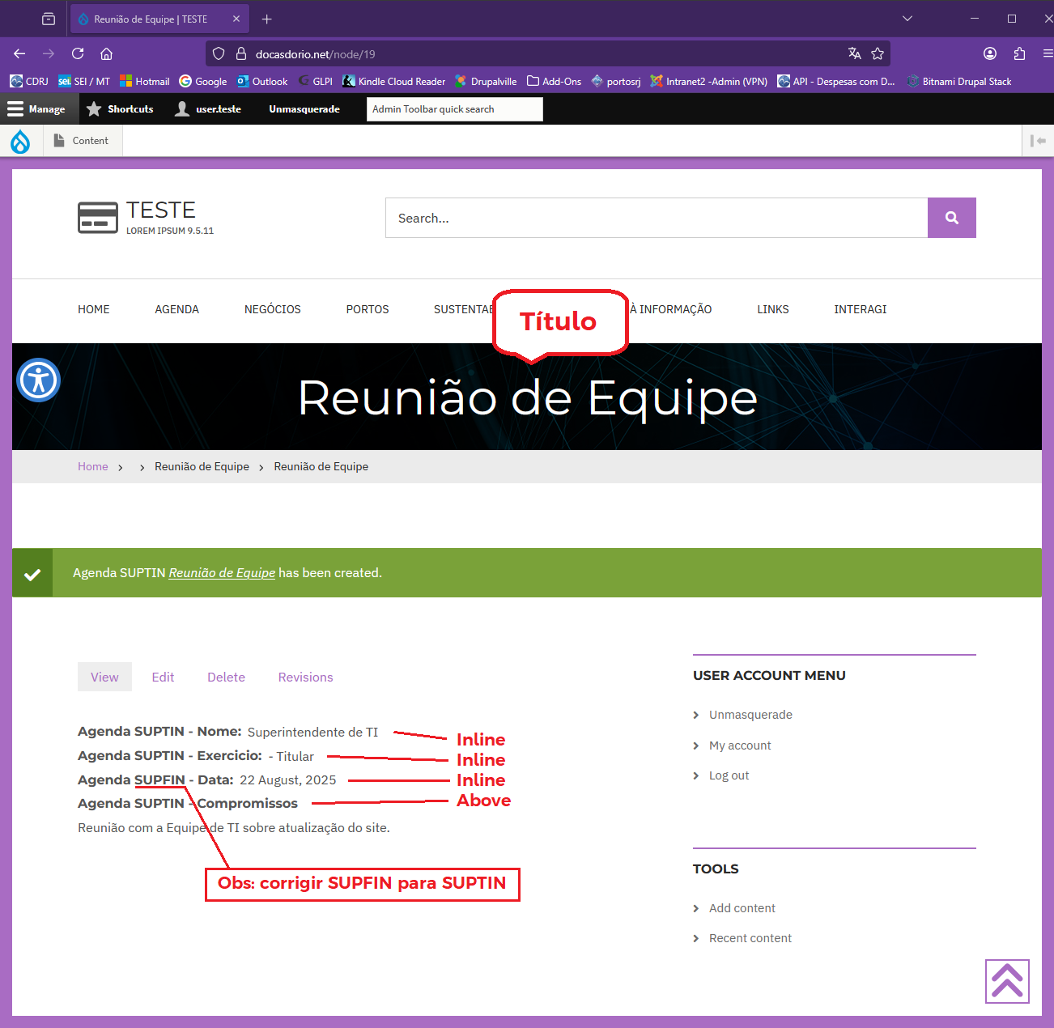

Oooops! Devemos corrigir o label de SUPFIN para SUPTIN !

Volte para ser administrador, removendo a máscara ao clicar em Unmasquerade caso tenha usado esse método ou saindo (Logout) do user.teste e logando como administrador.

Vá para:
Structure > Content Types > Agenda SUPTIN > ABA Manage Fields
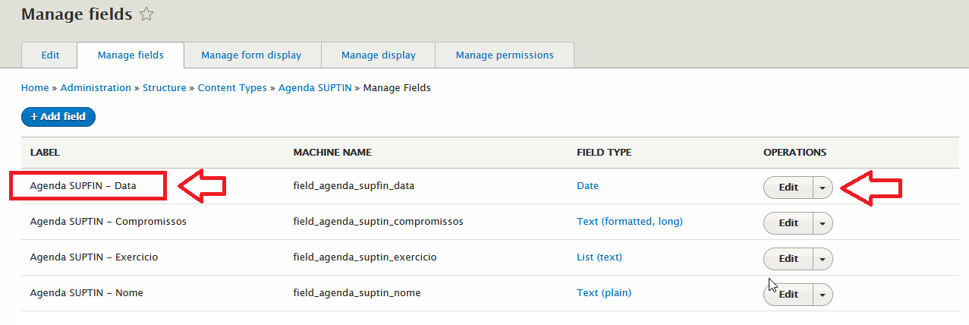

Clique em Edit
Corrigir o Label para Agenda SUPTIN – Data
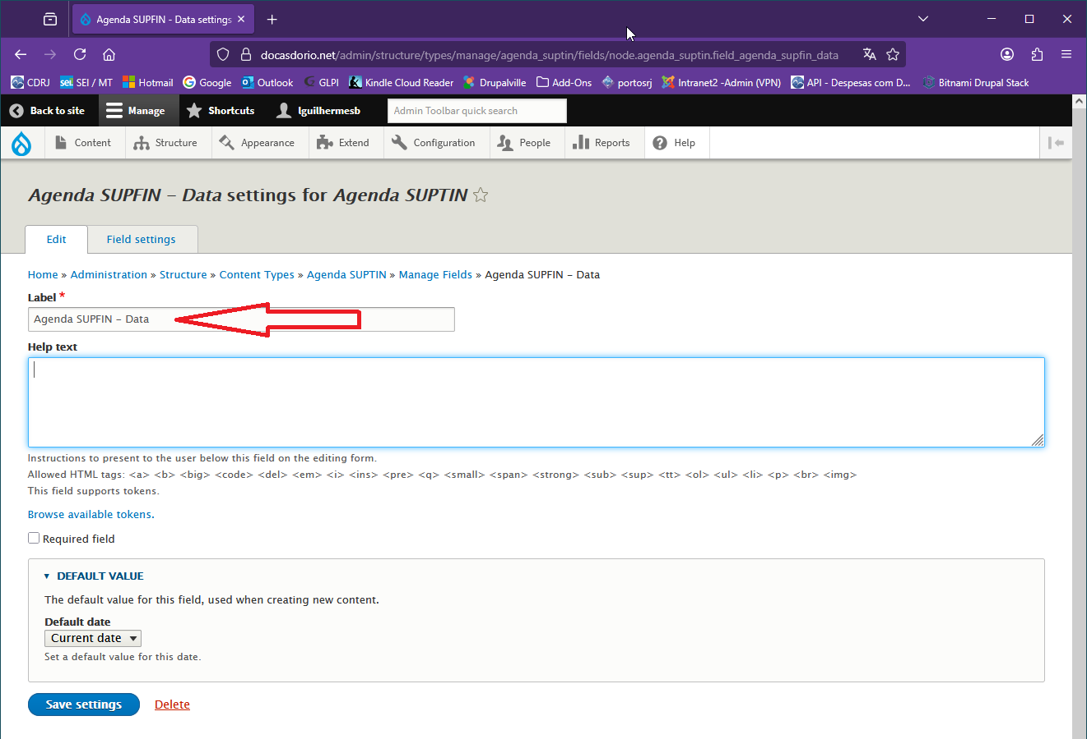
clicar em Save Settings

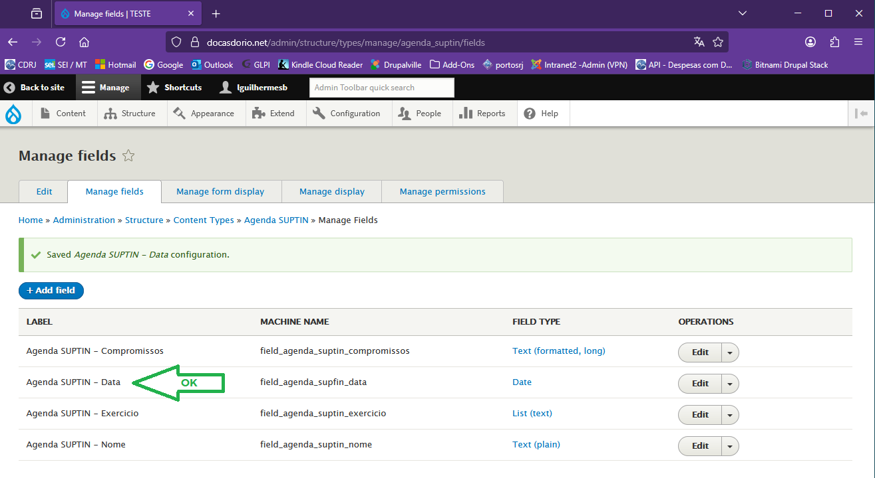

Ao corrigir o Label, a correção se fará automaticamente nas outras abas do Manage fields da Agenda SUPTIN.

Como ainda não temos pronta a View da Agenda SUPTIN, um recurso para ver se a correção foi bem sucedida é abrir o conteudo cujo título é “Reunião de Equipe”, que é o primeiro (ou um dos primeiros ) da lista de conteúdo.

Clique no menu Content
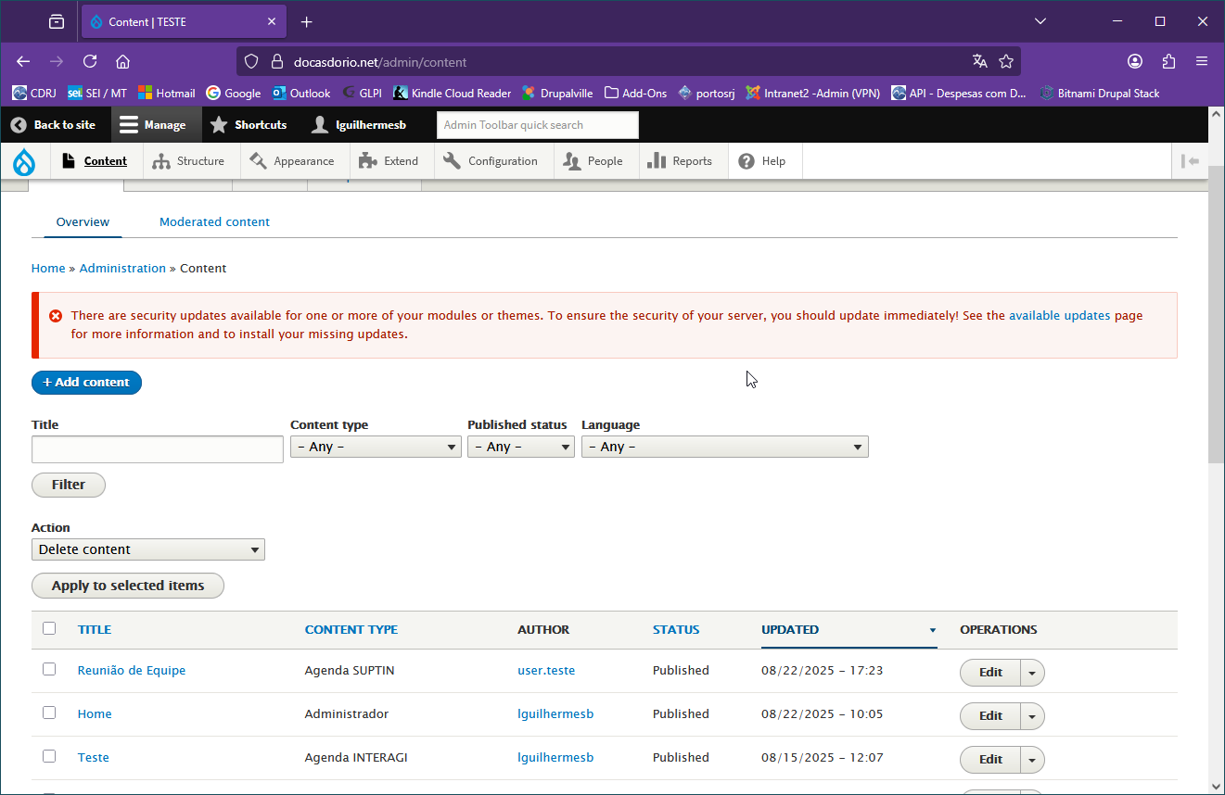

Clique sobre o link Reunião de Equipe para abrir o compromisso.
Pode editar se quiser. Para isso, basta clicar no menu Edit abaixo do banner do título

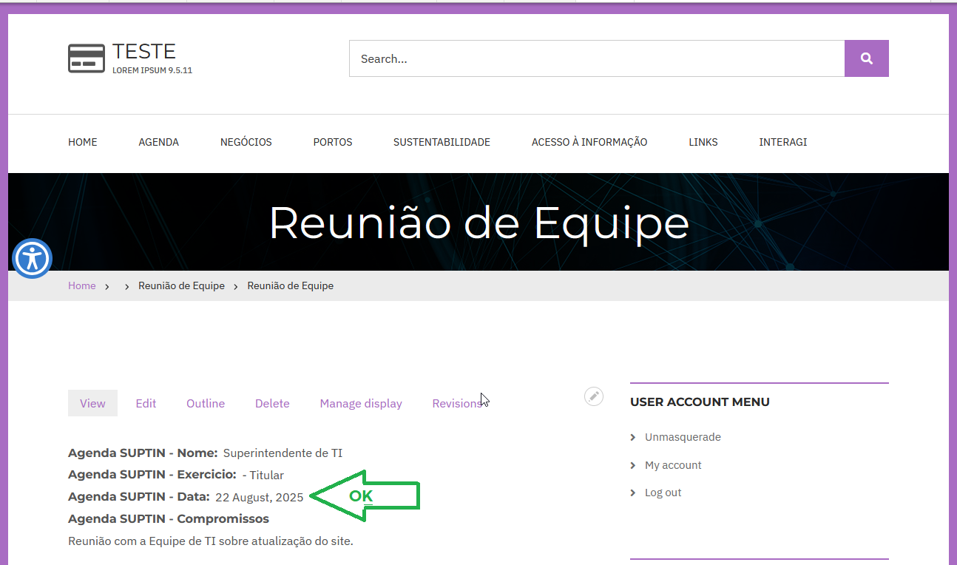
Label foi corrigido !

Log das Revisões
Para ver as revisões anteriores, inclusive quem editou a revisão corrente, clicar em Revisions

Vai abrir a tela Revisions for Reunião de Equipe

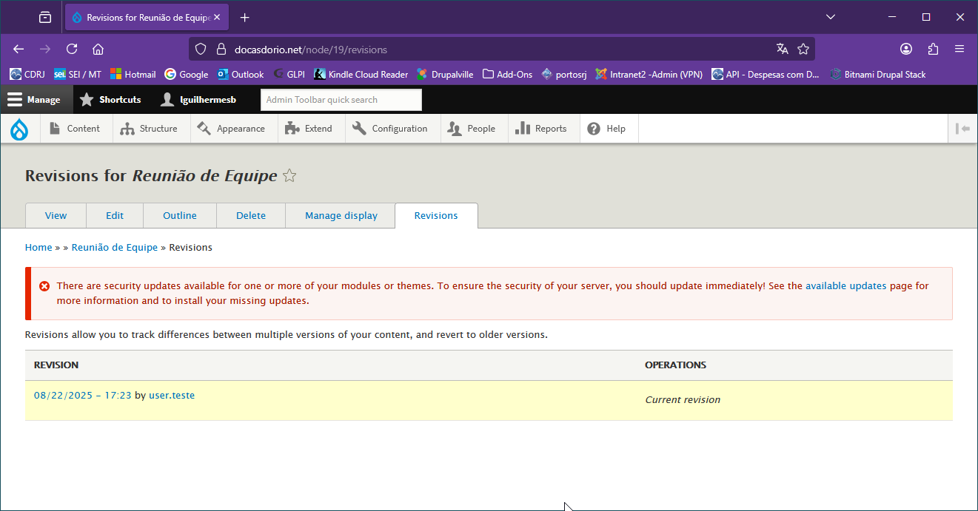

Como não existem salvas anteriores desta página, só aparece a revisão corrente, por user.teste em 22/08/2025 17:23
Para retornar, clique na aba Ver (View). Não confundir com “Views” que será visto a seguir.

Repassando os tópicos vistos até aqui:

1. Instalação do módulo da agenda – FullCalendar View
Administration > Extend > Add New Module

2. Criar o Tipo de Conteúdo (Content Type) Agenda SUPTIN
Structure > Content Types > Add Content Type
  - Adicionar os seguintes campos na aba Manage Fields do tipo de conteúdo Agenda SUPTIN:
Rótulo | Tipo do Campo (Field type )
Agenda SUPTIN - Compromissos | Text (formatted, long)
Agenda SUPTIN - Data | Data
Agenda SUPTIN - Exercício | List (text)
Agenda SUPTIN - Nome | Text (plain)

  - Organizar a aba Manage form display (Formulário)
  - Organizar a aba Aba Manage display (Exibição)

3. Criar o grupo de usuários (Perfil) P_Agenda_SUPTIN

4. Atribuir permissões ao grupo de usuários P_Agenda_SUPTIN:

5. Criar um usuário de teste no grupo P_Agenda_SUPTIN

6. Adicionar Conteúdo à Agenda SUPTIN (para testar o preenchimento do formulario pelo usuário)
Content > Add Content > Agenda SUPTIN

7. Corrigir o Label no campo Agenda SUPTIN – Data (estava errado: Agenda SUPFIN - Data)

Agora que criamos o tipo de conteúdo (Content type) Agenda SUPTIN, criamos o perfil de usuário P_Agenda_SUPTIN editamos as permissões referentes a este perfil e criamos um usuário de teste para verificar o preenchimento do formulário de compromissos, (ou inserimos um usuário real existente no perfil P_Agenda_SUPTIN), é a vez de criarmos a interface da Agenda SUPTIN como exibida na figura da pág. 5 usando o módulo já instalado FullCalendar View.

FullCalendar VIEW

Montando a View da Agenda SUPTIN:
Structure > Views > Add view

Queremos montar uma View com o nome Agenda SUPTIN exibindo o Conteúdo (content) do tipo Agenda SUPTIN
Repare que ao escolher o tipo Agenda Suptin (tipo de conteúdo montado previamente), os campos tagged with e sorted by desaparecem.

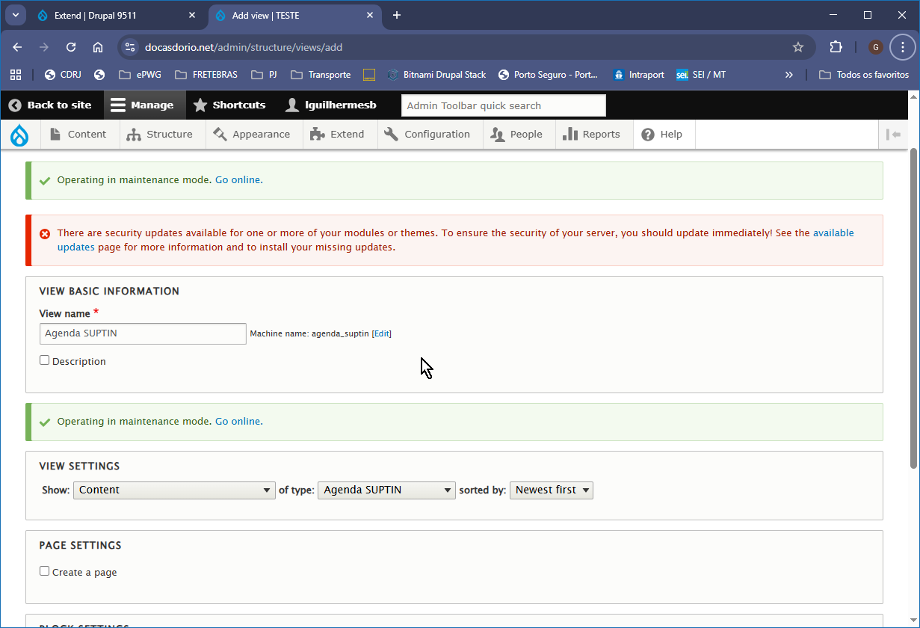

Existem dois modos:

PAGE SETTINGS
[ ] Create a page - A agenda será montada em pagina inteira com seu URL próprio.
ou
BLOCK SETTINGS
[ ] Create a block - A agenda será montada em um bloco a ser disposto em alguma região* do site

Vamos escolher o primeiro.
Ao escolher [x] Create a page, dois novos campos surgirão já preenchidos (podem ser alterados):
Page title [ Agenda SUPTIN ]
Path [ agenda-suptin ]

Clique [ Save and Edit ] se aceitar a sugestão dos nomes.
Vai abrir a tela Agenda SUPTIN (Content)

(*) Nota:
Regiões são posições específicas do layout de página que podem variar de posição, tamanho, quantidade e nome, conforme o tema escolhido para “vestir” o site. As regiões variam de um tema para outro e são nomeadas de acordo com as posições que ocupam na página, por quem fez o projeto daquele tema.

Algumas das regiões disponíveis no tema “Catalog Lite” usado no nosso site para posições específicas como Cabeçalho, Lateral esquerda, Conteúdo principal, Lateral direita e Rodapé, entre outras são: Header First, Header Second, Sidebar first, Content, Sidebar second, Footer bottom, apenas para citar algumas.Nem todas as regiões precisam ser ocupadas. As que restarem vazias ficam ocultas.

Para montar uma página são utilizados Blocos que podem conter texto formatado, links, listas, imagens e até Views. Daí a disponibilidade de escolher entre montar a View em pagina inteira com URL própria OU montar a View em um bloco, dando-lhe um nome.

O bloco contendo a View (ou algum outro tipo de informação).é então inserido em uma região determinada em relação à página (ou páginas) do site.
Existe uma infinidade de opções para posicionar o bloco em apenas uma determinada página, ou para determinar que somente usuários que fizeram login no site podem ver o bloco, ou ainda que aquele bloco só será mostrado em um grupo de páginas que pertença, a um Tipo de Conteúdo.
Exemplo: Posicionar o bloco de nome “CONTRASTE” (normal, letra amarela em fundo preto ou letra azul escuro em fundo azul claro), na coluna lateral direita.

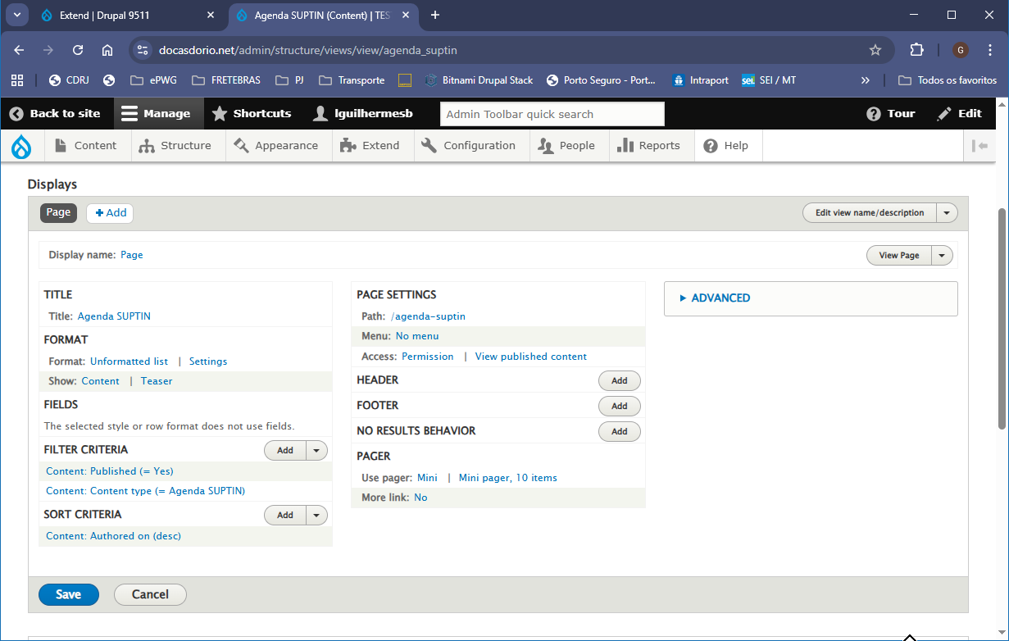

Vamos fazer as seguintes alterações:

FORMAT
Format: Unformatted list alterar estilo para Full Calendar Display

Clique em Unformatted list .
Abre-se a janela Page: How should thi view be styled
Escolha o Full Calendar Display
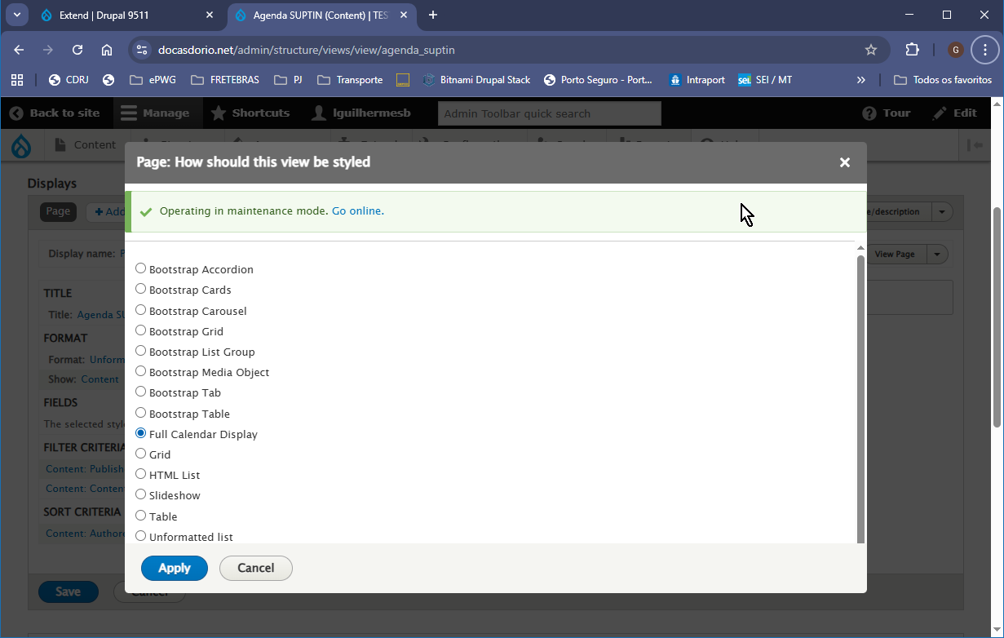
Clique [ Apply ]
Na proxima tela Page: Style options vamos deixar assim por enquanto. Retornaremos a ela após determinar os campos que queremos que sejam exibidos.
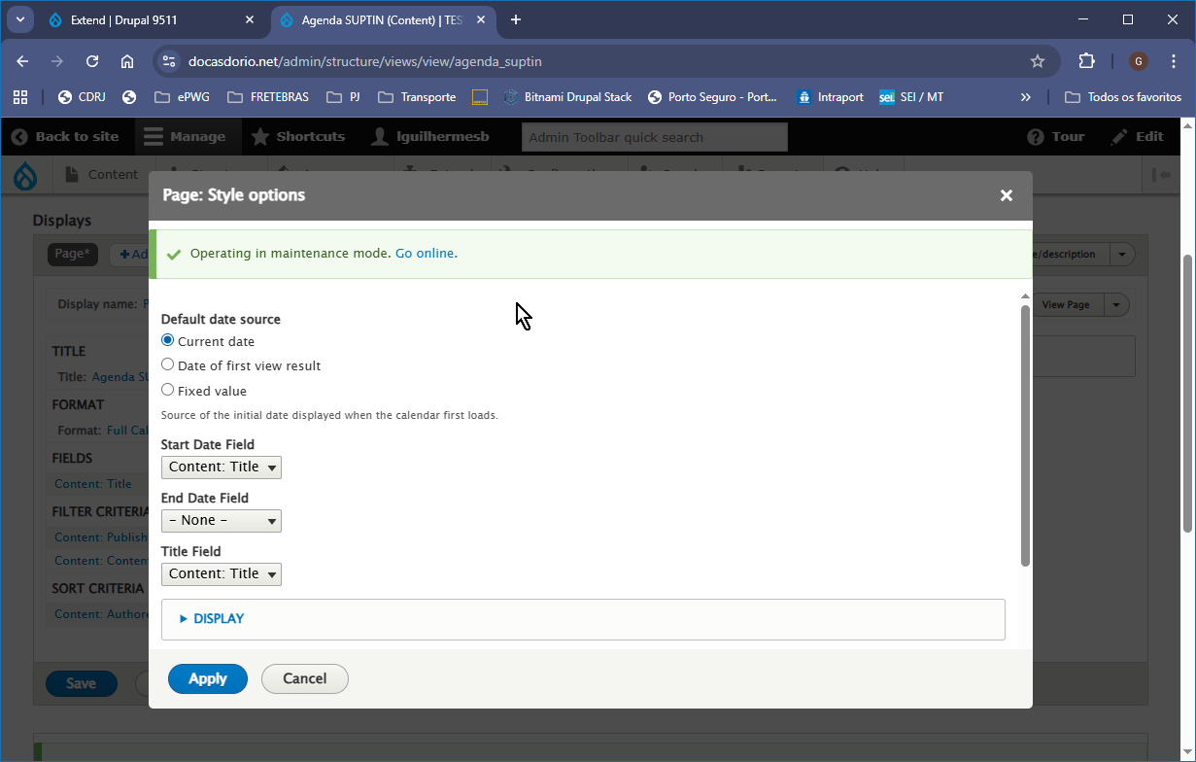
Clique [ Cancel ]

Adicionar os outros Campos (previamente deterninados anteriormente):
Conteúdo: Agenda SUPTIN - Data
Conteúdo: Agenda SUPTIN - Nome
Conteúdo: Agenda SUPTIN - Exercício
Conteúdo: Agenda SUPTIN - Compromissos

FIELDS (CAMPOS)
Conteúdo: Título - Este campo já está determinado na View
Clique em ( Add )
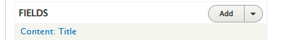
Digite a palavra SUPTIN na busca (Search) da janela Add Fields (Adicionar Campos)

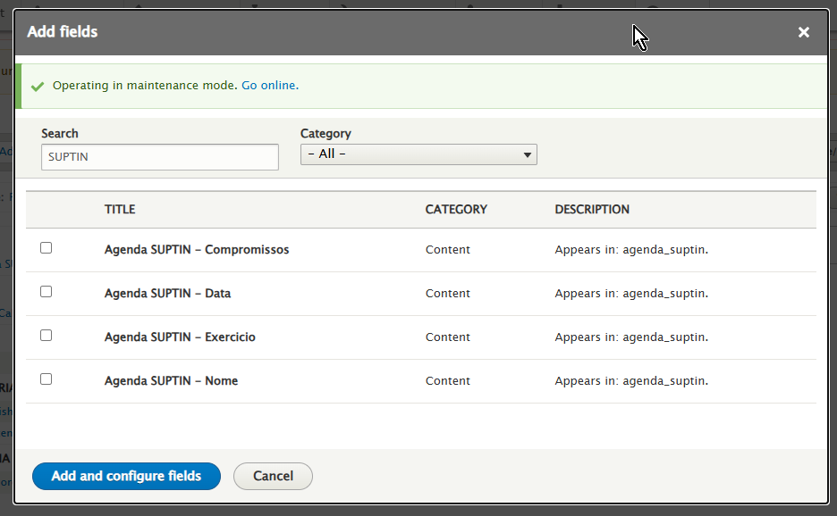
Marque todos.
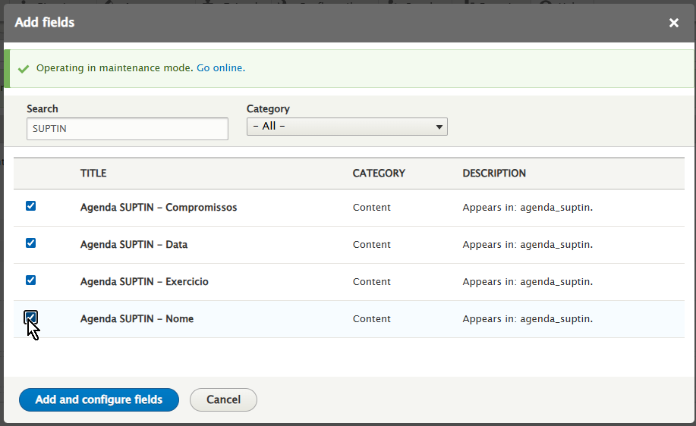

Clique Add and configure fields

A seguir, deverão ser configurados todos os campos marcados, um por vez: as janelas abrirão automaticamente.

Configure field 1 of 4
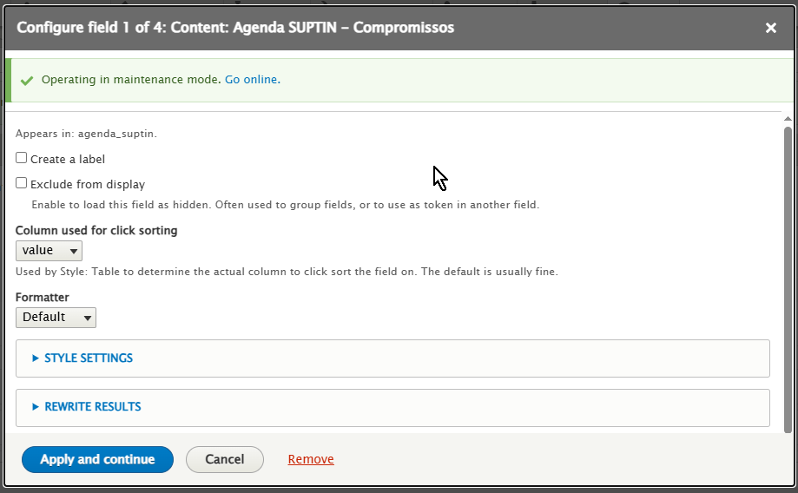
Clique Apply and continue

Configure field 2 of 4
Altere Time Zone para Sao paulo
Altere Date format para 25 August, 2025 (ou a data deste seu dia)
Obs.1: Certifique-se de definir um formato apropriado para o campo, ou seja, omitir a hora para um campo que contenha apenas a data como é no nosso caso
Obs.2: Voce pode determinar outros formatos de data que não estão listados, por exemplo o formato que eu chamei de Data curta sem a hora 25/08/2025
Em outro momento retornaremos a essa configuração de formato que é feita utilizando o PHP.

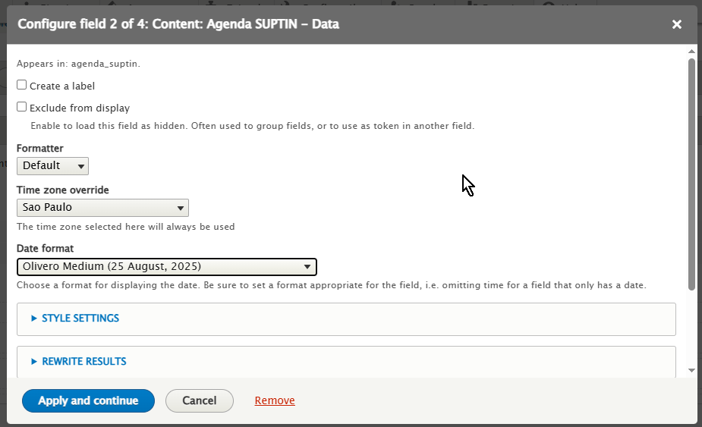

Configure field 3 of 4

Configure field 4 of 4

